The US Navy Japanese/Oriental Language School Archival Project

The Interpreter
Archives, University of Colorado at Boulder Libraries

Number 158 Remember September 11, 2001 | arv@colorado.edu April 1, 2010

Our Mission

In the Spring of 2000, the Archives continued the original efforts of Captain Roger Pineau and William Hudson, and the Archives first attempts in 1992, to gather the papers, letters, photographs, and records of graduates of the US Navy Japanese/ Oriental Language School, University of Colorado at Boulder, 1942-1946. We assemble these papers in recognition of the contributions made by JLS/OLS instructors and graduates to the War effort in the Pacific and the Cold War, to the creation of East Asian language programs across the country, and to the development of Japanese-American cultural reconciliation programs after World War II.

The JLS Experience
of T. Howell Breece

(Cont’d) The USS Sumner, a former coast and geodetic survey ship, carried me to Pearl Harbor. As far as Guam, I had a fellow passenger sharing my cabin, but he was so desperately seasick that he left ship at Guam and flew home from there. During the long passage from Guam to Pearl Harbor, I got the ship’s navigator to teach me how to navigate using a sextant and the HO214 tables of predicted azimuths and altitudes. I thoroughly enjoyed the passage. The Sumner was supposed to go through the Panama Canal and on to the Boston Navy Yard for a thorough refit. To the great distress of the Captain and his officers, two days before she reached Pearl Harbor a radio message told the Captain that when the ship reached Pearl Harbor, she was to turn around and go to Bikini to make a careful survey of the atoll. No one knew why, but of course, later it became clear that the survey was in preparation for the test of the first hydrogen bomb. Since I was a mere passenger, I did not have to go to Bikini with the ship. Instead, after a few days wait, I boarded an escort carrier now serving as a passenger ship for the five day voyage from Pearl Harbor to the Alameda Naval Station in San Francisco Bay. (to be cont’d)
T. Howell Breece
JLS 1944
_______________

James M. Wells
30 Years at the Newberry
56 years a Caxtonian
And Enjoying Every Minute

(Cont’d) “I learned my way through the collection,” he said. He joined the Caxton Club and the Society of Typographic Arts. There was a calligraphy study group, and a printing workshop was set up in the basement of the Newberry. He had interesting readers and excellent colleagues,
including Hans Baron, Gertrude Woodward, Ruth Butler, Ben Bowman, David Stam, and Bob Karrow.
Soon there were additional responsibilities, as well. When Ken Davis resigned as editor of the Newberry Bulletin, Wells took over. “I got to write the articles about notable acquisitions, which was a pleasure. And I found that commissioning articles also gave me satisfaction, because of getting to know new people and working with them to shape their
articles.”
Lawrence Towner replaced Stanley Pargellis as President of the Newberry in 1962. Where Pargellis had been thrifty, Towner was expansive. Towner set about using the nest egg that Pargellis had accumulated for staff, facilities, and holdings. Eventually Wells was in charge of acquisitions, fellowships, education, and publications at the Newberry. Then the process was reversed, as staff was found to be responsible for specific areas, and Wells was freed up to work on acquisitions.
“Towner spent his time raising money,” Wells explained. “I spent my time spending it.”
Every other year, Wells would visit London and Paris on a shopping trip for the Newberry.
He particularly remembers two booksellers. In Paris, it was André Jammes. “His grandfather had been a bouquiniste [stall owner], his father had moved into a store, and he became an antiquarian dealer. During the course of the two years between my visits he would put items he expected us to want in a closet. When I would arrive, I’d take a week going through the closet.”
The experience with E. P. Goldschmidt in London was similar, but with a difference: Goldschmidt was a night owl, and particularly disdained mornings. So “He would invite me to his apartment at 11 p.m., and show me books until the wee hours.”
The large acquisition of which Wells is most proud was the Louis H. Silver collection. Wells was familiar with the collection from having visited Silver and his wife, Amy (who acted as his bibliographer) at their Wilmette home. The books
(many of them acquired from famed bookseller John Fleming, himself the successor to the even more famed A.S.W. Rosenbach) were housed in a vault that had room for a table and easy chairs. Silver was a hotelier; he had put his companies at risk by purchasing the Ambassador hotels, an over-extension of resources and perhaps his capabilities. To secure a loan, he used his books and prints as collateral. With his untimely death in 1963, the books had to be put on the block. At first, a rumor circulated that the collection was going to go to the University of Texas. But Wells did some research and learned that it was not a settled agreement. Wells went to Towner, who went to the board of trustees with a plan.
Although the en-bloc cost of the collection was expected to be $2,750,000, Wells argued that a large portion could be recouped through the auction sale of books
that were duplicates of ones already held by the Newberry. Furthermore, many of the items in the collection were famous and would be good candidates to solicit individual donors to underwrite. Towner proposed the sale of stocks and bonds from the endowment to fund the purchase.
The trustees approved the plan. The Newberry acquired the collection.
Shortly thereafter, an auction at Sotheby’s returned more than $800,000 for the duplicates. In the process, the Newberry received international publicity. Word reached Wells that the New York Times was going to cover the story, so he quickly called in the Tribune, Sun-Times, and Daily News for a press conference. The local papers responded with front page stories the next day. Sotheby’s was proud enough of the subsequent auction that they made a documentary about the sale that circulated for years.
Among the curious consequences of the deal was that anyone and everyone offered
their books for sale to the library. The Towner papers at the Newberry have a folder, 3/4 of an inch thick, of letters from people who believed that their collections belonged there.
(to be cont’d)
Robert McCamant
The Caxtonian
Vol. XV, No. 9
September 2007
_______________

An EAA Interview
with
Houghton Freeman

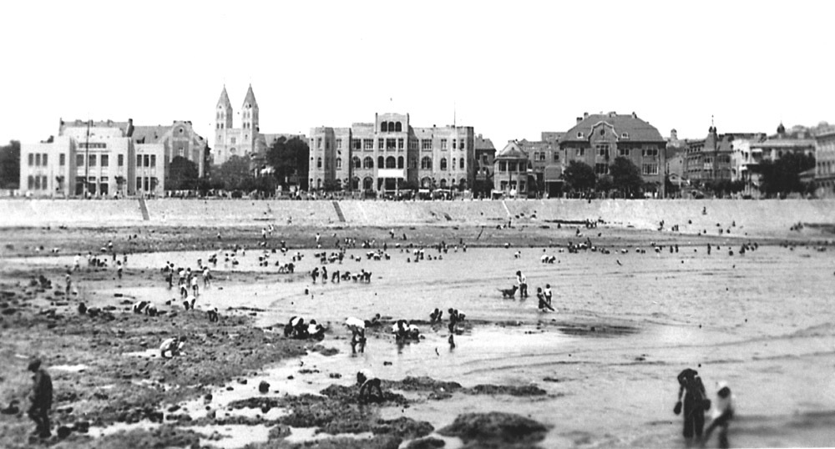
Shanghai
http://www.haroldstephens.net/image/tid/51?
(Cont’d) Lynn Parisi: Doing business for AIU in postwar Shanghai, you again witnessed a pivotal chapter in Chinese history. By 1948 when you returned, the communist victory in the civil war was close at hand. What were your impressions of the civil war? What was Shanghai like, prior to and following the Chinese Communist Party (CCP) victory, for American businesses and individuals?
Houghton Freeman: The communists came south towards Shanghai in spring 1949, a year after we arrived. By May, they had surrounded Shanghai. We were really looking forward to their arrival because the Guomindang were so corrupt. Inflation had become impossible – you had to carry around bags of money to do business.
Lynn Parisi: Do you mean the company was looking forward to CCP rule or individuals were hopeful about the change?
Houghton Freeman: The company, yes, but also as individuals we were looking forward to it. We were all disillusioned with the Guomindang. Of course everyone was anti-communist in those days, but in the context of China at that time, we saw the communists as another entity, a chance to change things for the better given what China was like under the Guomindang. We thought it would be an improvement.
We discovered within forty-eight hours of their takeover that it wasn’t going to be. Our newspaper, the Shanghai Evening Post and Mercury, had an editor, Randall Gould, who was stubborn. He thought he would test the new regime by running an editorial that was pretty anti-communist, and the newspaper was immediately censored. Gould refused to compromise and within two months, I think, the communists had closed the newspaper.
All the American companies had instructed families to leave Shanghai just before the communists came that spring, but Doreen was six months pregnant, refused to go, and remained with a few other women. Some people within AIU left early on – especially those who had been interned under the Japanese and who were still recovering from that experience. Our Chinese senior management all left for Hong Kong very quickly. Finally, there were four foreigners left at AIU – Doreen, myself, and two others. Other foreigners who stayed were also from companies with big stakes in Shanghai – oil companies, banks, large trading companies.
We hoped things for the insurance industry would be okay, but they weren’t. It was no longer a question of what was legal in an insurance policy; things were settled with the person who had the money paying the one who did not. So, in all car accidents, they guy who had the car had the money. If two cars ran into each other, decisions were made based on who had more money. We couldn’t do business like that. However all our policies were twelve-month policies and the communists required us to stay open until the last policy expired. C.V. Starr put one person, Charles Minor, in charge of closing operations for AIU in China and advised the few of us still there to leave when we could. Business had come to a halt. Of course, Doreen and I couldn’t leave because by then she was eight months pregnant with our daughter Linda. There wasn’t much for one AIU’er and I to do but check in at the office in the mornings, then take rickshaws up to the British country club on Bubbling Well Road, have lunch, swim, then head back to the office.
In late summer 1949, we also had to deal with labor strikes at the Shanghai Evening Post and Mercury. Newspapers involve a lot more personnel. Laborers were making sky-high demands for payment. Gould, the editor, moved to our offices because his offices were surrounded by unfriendly employees. But all of his laborers followed and protested at our offices and “locked him in.” No food; only water or Chinese tea. It was a mess for a few days – but finally settled – though, by the end, Gould was pretty much a basket case. (to be cont’d)

Education About ASIA
Vol. 12, No. 2
Fall 2007
Reprinted with permission of the
Association for Asian Studies, Inc.
_______________

Conversation
Between Marines

Dear Aubrey [Farb]:
Major General Eiji NAGANO was the commanding general of the 5th Independent Mixed Brigade [Japanese Imperial Army], which had comprised the troops in Tsingtao and its environs. I do not recall how many troops were under his command. The Marines were engaged in loading ships with Japanese troops and civilians to be returned to Japan. While the repatriation program was in motion, a substantial number of Japanese troops remained at their posts in the country outside Tsingtao, awaiting release for shipment home. Since we could not repatriate everyone at once in any case, it suited our logistical and tactical purposes to leave these troops positioned where their presence would deter incursions by Communist irregulars or just plain opportunistic bandits. Put another way, these surrendered troops contributed to our security.
General NAGANO maintained his headquarters just outside Tsingtao, and he cooperated fully in the management of his troops leading to their repatriation. In late November, he sought General Shepherd's permission to visit his troops "in the field". Permission was granted, with the proviso that he be accompanied by Marine observers. The G2 detailed two of us to the mission, Sgt. George Kline and myself. I do not recall having received written orders, When we arrived at the General's compound, I asked our Marine driver to take pictures of our group, using my locally acquired [I love such phrasing, like “midnight reclamation”?] Super Ikonta-B camera. I took the camera with me on our ensuing trip. I regret having lost the trip report that I was required to produce on our return. Our tour was made in the General's dilapidated staff car, accompanied by three very beat-up trucks. The 5th IMB had of course been relieved of the better part of its motor transport by the Chinese at this point. Sgt. Kline said he would ride in one of the trucks, since it might be awkward for him to ride with officers. The General said there was no problem, and he should ride with us if he wished. He did.

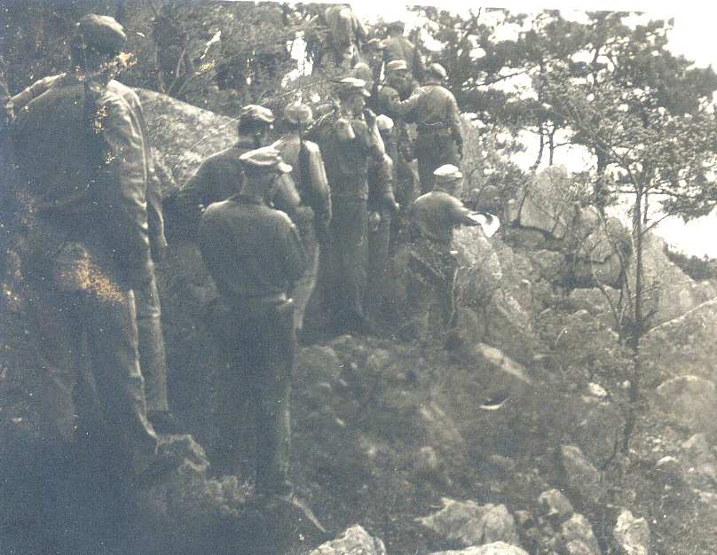
hikes in the Loh Shan Mountains above Tsingtao.
http://www.haroldstephens.net/node/371

We drove around in the Lao Shan mountain area but I do not remember the other place names. The troops we visited were quartered in small wooden barracks. Their morale appeared to be good and they seemed pleased to have their General visit them. One soldier, to whom I spoke, a sergeant, expressed his appreciation to the US for having allowed the visit. Under the conditions of our three-day association, and frequent contact during the proceeding repatriation, I found the General an impressive officer, not at all what I might have expected. Very tall for Japanese, he was soft-spoken and articulate, and we developed a very agreeable working relationship despite our disparate ranks. During our tour we sluiced the dust from our throats with numberless cups of tea (but nothing stronger!)
Some time after our trip the General sent an aide to invite me to his quarters. Over tea he said he had a problem with which I might be willing to help him. He said that the Japanese military had all been disarmed, and civilians had been required to turn in any arms, including swords. The General said that an elderly Japanese man whom he knew had asked his help. The old fellow had been working for a long time to restore an old Japanese sword, which had deteriorated because of improper maintenance. This involved painstaking polishing by hand with a very fine abrasive. The job was only partially completed. He had not turned in the sword, leaving him vulnerable to arrest; nor did the General dare to become directly involved. So - could I take the sword and "make it disappear"? I did, and made it disappear into my luggage - from China to Kyushu, Japan and to the U.S.
When I returned to Japan as a civilian, several years later, I brought the sword and showed it to an official Japanese confrere who was a sword fancier. He said that the markings on the hilt showed that it was very old and probably valuable. As he suggested, I took it to JAPAN SWORD KK, the premier company doing sword work. They polished the blade into well-nigh perfect condition and said it was indeed valuable. During that period I went to the Demobilization Bureau to find out if the General had returned to Japan. They couldn't tell me, blaming chaotic record keeping.
(to be cont’d)
Semper Fi
Glenn Nelson
JLS 1944
_______________

Reprise on
Benjamin Price

As an aside, when my father-in-law [Benjamin Price] was assigned to the American Embassy in London in 1975, 34 British Members of Parliament, most of them associated with the left wing of the governing Labour Party, named ten “attachés” (including my father-in-law) who, they believed, were actually working for the CIA, and demanded their expulsion. I am not sure which would have been more distressing: to be named in the press, or to be mischaracterized as a CIA operative.
J. Stephen Turett
_______________

Robert L. Crispin
OLS 1944
1917-2007

Robert Leroy Crispin, 90, died comfortably and at peace on August 14, 2007, in the Transitional Care Unit of the Meadville Medical Center. He was the husband of Vera Krieghoff Crispin, to whom he has been married since June 18, 1940.
Bob was born in Central City, Colorado, on April 19, 1917. He was descended from a long line of Cornish tin miners who came to this country in the late 19th century to work in the silver mines of Colorado [The Cornish were the expert single and double jack drillers and black powder blasters in the deep rock silver and gold mines of the American West until electric drills and dynamite bypassed their skill set – the Archives has a considerable collection of mining records]. He was educated at the University of Colorado, where he met his beloved Vera, and at Penn State University, from which he earned his Ph.D. in German Language and literature. He was also a graduate of the United States Navy Japanese Language School, after which he was assigned to the Joint Intelligence Center, Pacific Operating Area (JICPOA) at Pearl Harbor during World War II, and the Naval Fleet Intelligence Center, Yokosuka, Japan, during the Occupation.
Bob taught German and Spanish language courses at Allegheny College from 1942 to 1982. He was also on the German faculty for the summer program at Colorado College and a lecturer at Penn State, and served as a Visiting Lecturer at the University of Innsbruck, Austria. From 1970 to 1972, Bob was the Dean of the Regional Council of International Education in Basel, Switzerland.
During his life in Meadville, Bob was involved with several community organizations. He was a Board Member and President of the Crawford County Literacy Council, served on the Executive Committee of the Meadville Area Soup Kitchen, volunteered for many years at the Meadville Medical Center, was a member, past president, and van driver for the Crawford County Unit, American Cancer Society, and was a story hour reader at the East End Elementary School. He was also an active member of and dedicated to the Meadville Unitarian Universalist Church for 53 years.
In addition to his wife of 67 years, Bob is survived by his three children and several great grandchildren: his daughter Karen and her husband Richard Jessup of Providence, Rhode Island; and their children Dana Jessup, her husband Brian Turner and their daughter Lydia, of Milton, Massachusetts; Amy Scaramella and her husband Luke, and their daughters Karaline and Hope, of East Greenwich, Rhode Island; and Kara Della Croce and her husband Matthew, of Los Angeles, California; His son Robert and wife Kathy Frisk Crispin, of Scarborough, Maine; and their children Jon Crispin and his wife Kirsten, and their daughters Kendall and Jenna of Northbrook, Illinois; Debbie Duryee, and her husband Burr, and their children Crispin, Piper, and Campbell, of Cape Elizabeth, Maine; and Heather Polk and her husband Tyler, of West Hartford, Connecticut; and his son Jon Crispin, his wife Cristine Smith, and their son Peter, of Pelham, Massachusetts.

Memorial Program
“Celebrating the Life of
Robert Leroy Crispin”
October 28, 2007

[Ed. Note: Bob Crispin was an enthusiastic supporter of the USN JLS/OLS Archival Project from the beginning. He wrote or was mentioned in Issues: #38, #39, #43, #47, #71 “Stoffle’s ‘Awful Waffle’ Shop”, #73 Lt. William G. Beasley, Royal Navy, OLS 1944,Remembered, #84A, and #86. After his comment about having worked at the “Sunken Gardens,” I went over to the Sink with an enlarged copy of his signature and a Sharpie® and wrote his signature on the ceiling with his JLS date and CU class year, where it remains with the other current, student graffiti to this day.
His name always reminded me of one of my favorite dramatic speeches from Shakespeare, and possibly the best military pep talk and veterans’ honorific. I submit it here for all those of the USN JLS/OLS, here and gone:
“This day is called the feast of Crispian: He that outlives this day, and comes safe home, Will stand a tip-toe when the day is named, And rouse him at the name of Crispian.
He that shall live this day, and see old age, Will yearly on the vigil feast his neighbours, And say 'To-morrow is Saint Crispian:' Then will he strip his sleeve and show his scars. And say 'These wounds I had on Crispin's day.'
Old men forget: yet all shall be forgot, But he'll remember with advantages What feats he did that day: then shall our names.
Familiar in his mouth as household words Harry the king, Bedford and Exeter, Warwick and Talbot, Salisbury and Gloucester,
Be in their flowing cups freshly remember'd.
This story shall the good man teach his son; And Crispin Crispian shall ne'er go by, From this day to the ending of the world, But we in it shall be remember'd;
We few, we happy few, we band of brothers; For he to-day that sheds his blood with me Shall be my brother; be he ne'er so vile,
This day shall gentle his condition:
And gentlemen in England now a-bed Shall think themselves accursed they were not here, And hold their manhoods cheap whiles any speaks
That fought with us upon Saint Crispin's day.”
William Shakespeare
Henry V
(IV, iii)]
Dear Mr. Hays:
I am writing to let you know that my Dad, Robert L. Crispin, who attended the US Navy Japanese Language School and took a keen interest in your archives project, died on 14 August 2007. My 93 year old Mom, Vera Krieghoff Crispin (a CU alumna) survives. I am including with this letter a copy of the program from Dad’s memorial service. He was very proud of his naval career and enjoyed reading The Interpreter ….
Dad had a wonderful life with tremendous friends, among whom he counted his Navy buddies. We mourn his loss, but celebrate him as a caring humanitarian who was shaped, no doubt, by his experiences and associations from the Language School and overseas deployment.

Karen L. Jessup, Ph.D.
_______________

An Economist of Japan
&
The JLS Longevity Contest

This is my response to your proposal (perhaps just kidding) [yes] of a contest on the longevity of JLS graduates – in your latest Interpreter [#120] referring to a JLS/OLSer who will be 93 years old next August.
The fact is that I will be 94 in March 27, 2008, and was therefore ahead of that guy – although not necessarily ahead of some others. I am in excellent health, and very active here in South Florida in winters and New Jersey in summers.
Since I graduated from JLS in March 1944, I have used my Japanese first in Naval Intelligence, then extensively in my career as a professor, economist and traveler.
I was the member of the “large class” that started at Boulder in January 1943, and graduated in March 1944. During most of that period I lived off-campus in an apartment, with my wife Beatrice. Romantically enough, she came out by train from Washington, DC, and we married at once.
After graduating, I served in the Navy’s Intelligence Center (JICPOA) in Hawaii during 1944-1945, translating captured documents and interrogating captured Japanese personnel (happily, no “water-boarding” in those days!) . In August 1945, I was at sea on the flotilla approaching Japan for invasion when the dropping of the atomic bombs put an end to the war.
I then served in Kyushu, in Tokyo, and in Washington, DC, as a member of the Strategic Bombing Survey, in charge of studies of Japan’s Wartime Economy. Returning to the US, and honorably released from the Navy (as Lieutenant Senior Grade), I devoted myself to completing my Ph.D. degree in Economics at Columbia [Stand Columbia!], by doing my dissertation on Japan’s economic development from 1860 to 1935, using my knowledge of the language to draw upon many economic and social documents not previously available to Western scholars who could not read Japanese. My dissertation demonstrated Japan’s skills at modernizing and industrializing their economy, with hardly any reliance on foreign capital or direct investments from abroad. With my wife’s participation, we published an article in the prestigious journal Quarterly Journal of Economics, August 1947, on the little-known “Small-Scale Industry in Japan”. This article, I was told, activated a number of other scholars; and it also led to my appointment as assistant professor of Economics at Cornell University, especially for the East Asia Program there.
In subsequent years I have made use of my Japaese in field trips to Japan as sponsored by the United Nations and the German Marshall Fund.
In 1952, I transferred from Cornell to the City College of New York, and served for six years as Chairman of the Ph.D. Program in Economics at the newly established Graduate Center of the City University.
Since I retired, my wife and I have moved to Florida, where I am continuing my professional activities by lecturing, writing two major articles in journals, also OpEd pieces in local newspapers.
Let’s hear from other long-lived graduates of the JLS!

Edwin (Ned) Reubens
JLS 1944
16259 Laurel Drive
Weston, FL 33326
nreubens@msn.com
945-389-7296
_______________

CU 'Red Scare' target dies

Faculty members praise Morris Judd's legacy

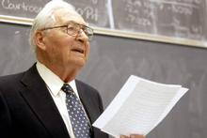
Photo by Mark Leffingwell

Morris Judd, the last surviving member named in a McCarthy Era report by the University of Colorado, has died. Judd was dismissed from the university in the 1950s after refusing to answer questions about his political beliefs in a CU inquest that produced the secret 126-page report, which was unsealed in 2002.
The last surviving University of Colorado faculty member investigated and fired during the "Red Scare" has died at age 91.
A celebration of Morris Judd's life was held in Denver on Wednesday -- one day after his death and a half-century after he was thrust into the center of an investigation on CU's campus for Communist members of the faculty.

Judd was dismissed from the university in the 1950s after refusing to answer questions about his political beliefs in the CU inquest that produced a secret 126-page report. CU's Board of Regents voted 50 years after Judd's firing to make public that document, which had been locked away in a bank vault.
It confirmed what many people had suspected was the real reason for Judd's dismissal: His name had been added to a list of suspected subversives because he wouldn't give a straight answer to former CU President Robert Stearns' questions, "Are you a member of the Communist Party," and "Have you ever been a member of the Communist Party?"
Stearns originally said Judd was let go because he was a boring teacher -- even though his department had judged him the most valuable of its instructors, upped his pay and recommended his promotion.
When the secret report was released in 2002, Judd was awarded a medal for his service to academic freedom.
"On one side, he did live to expunge his reputation and get back his name," said former CU Regent Jim Martin, who pushed for the report's release. "But certainly his life and career was totally changed."
Judd, who was living in Arizona at the time of his death, said in 2002 that the 1950s inquest was an invasion of his constitutional rights.
"This represents what can happen when the government and institutions, out of fear, try to brand people," Martin said.
CU English professor Paul Levitt, who helped open the secret report and published a book on the McCarthy Era at CU, said Judd told him recently that he didn't want to keep around the stacks of paper piled up in his basement from the 50-year-old controversy.
"I asked him if he kept all the papers from the '50s, and Morris said, 'Funny you should ask, a week or two ago I saw all those papers and I wanted to get rid of all those bad memories,'" Levitt said. "So he burned them all."
Levitt said he would have liked to donate the documents to CU's Norlin Library because of their historical significance.
"I think everyone in this university should be introduced to the dark side of the '50s at CU," he said. "One would hope they would be disinclined to repeat it. But history does repeat itself."
After Judd was banished from the university, he worked for his family's business in Greeley. He also worked in the travel industry and property development, according to his family.
Levitt said Judd impressed him because even after his name was cleared, Judd "never railed or screamed."
"He was a man of great poise and dignity," he said. "He had virtually every injustice visited on him, and you never once heard him complain or whine."

Vanessa Miller
Boulder Daily Camera
Thursday, February 21, 2008
_______________

William J. Hudson Jr.
William J. Hudson Jr., 85, formerly of Palm Beach, died Wednesday, Aug. 27, 2008, at his home in West Palm Beach.
Born in Maryland, he was a graduate of Princeton University in 1947 with a degree in classics.
Mr. Hudson's studies were interrupted during World War II, when he joined the Navy in November 1942 and attended the U.S. Naval Japanese School in Boulder, Colorado.
Mr. Hudson served as a translator and interpreter for repatriation of Japanese prisoners of war.
Following the war, he worked for Palm Beach resident Robert Young, chairman of the board of the New York Central Railroad. Mr. Hudson subsequently became a stock analyst and investor.
He is survived by his wife, Claudia Wampole-Hudson; a brother, Dr. Paul C. Hudson of Maryland; and a sister, Mrs. Carroll Swarm of Maryland. Mr. Hudson was preceded in death by his first wife, Florence Lowe Hudson.
Palm Beach Daily News
Saturday, August 30, 2008

[Ed. Note: Bill Hudson and Roger Pineau began this project in the 1970s. We only carry on their efforts. He was always writing me. RIP Bill, we’ll miss you.]
__________

