The US Navy Japanese/Oriental Language School Archival Project

The Interpreter
Archives, University of Colorado at Boulder Libraries

Number 164 Remember September 11, 2001 | arv@colorado.edu October 1, 2011

Our Mission

In the Spring of 2000, the Archives continued the original efforts of Captain Roger Pineau and William Hudson, and the Archives first attempts in 1992, to gather the papers, letters, photographs, and records of graduates of the US Navy Japanese/ Oriental Language School, University of Colorado at Boulder, 1942-1946. We assemble these papers in recognition of the contributions made by JLS/OLS instructors and graduates to the War effort in the Pacific and the Cold War, to the creation of East Asian language programs across the country, and to the development of Japanese-American cultural reconciliation programs after World War II.

Arthur R. Dornheim
Foreign Service Officer
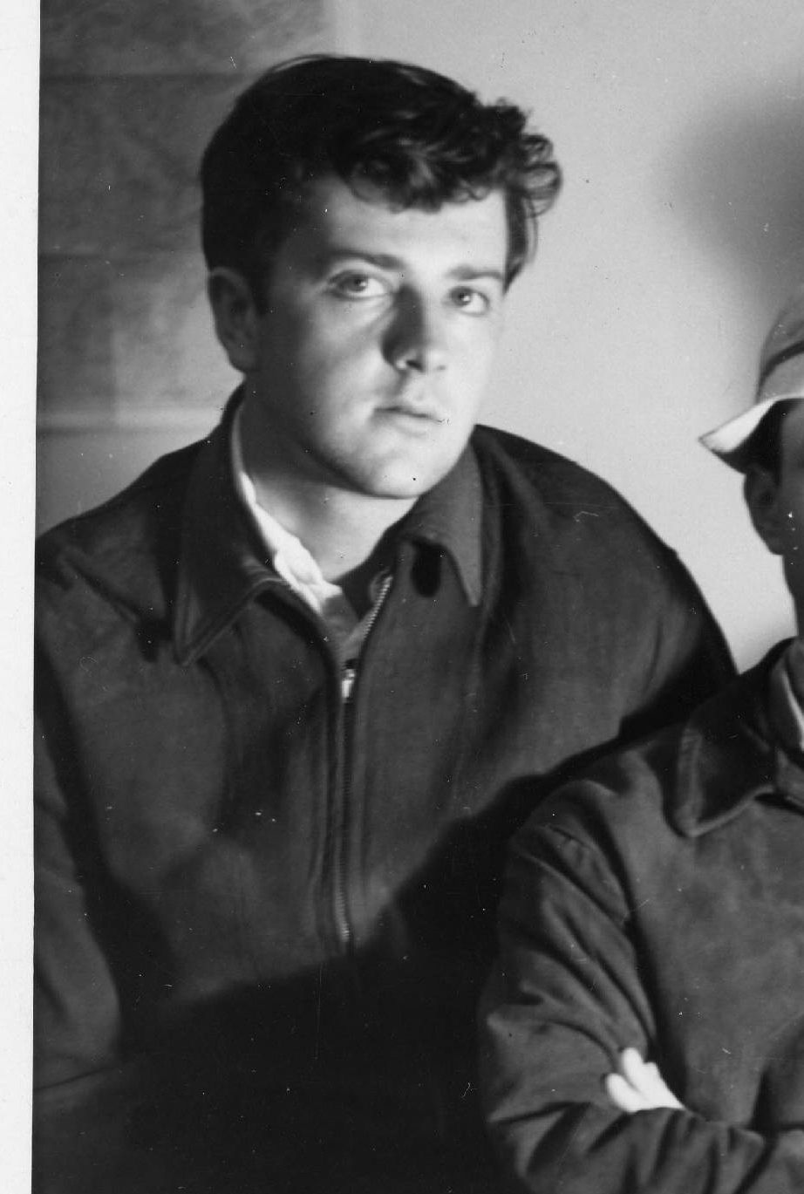

Dornheim at USN JLS/OLS at CU
In 1942-43

Arthur Rieper Dornheim, 87, a Foreign Service officer who retired in 1977 and spent 11 years as an executive with the Japan-American Society of Washington, died of pneumonia June 23, 2008 at Suburban Hospital.
Mr. Dornheim was born in Manhattan, New York, and grew up in Bronxville, New York. He was a 1942 graduate of Yale University.
He attended the US Navy Japanese Language School at the University of Colorado in Boulder from July 1942 to October 1943. He served as a Navy Japanese Language Officer in the Pacific as a translator and escort of Japanese Prisoners of War. After the War, he was assigned to the Occupation Forces in Japan.
After his service in the Navy, he received a Master’s Degree in international affairs from Columbia University.
Mr. Dornheim joined the State Department in 1949 and became a Foreign Service economics officer, serving until 1977. His assignments included: Hong Kong; Addis Ababa, Ethiopia; and Taipei, Taiwan.
In retirement, he became the first full-time staff member of the Japan-American Society. He served as executive director and later as associate director.
A Bethesda, Maryland, resident, he also worked in the children’s department at a Bethesda bookstore and was treasurer of the Battery Park Citizen’s Association in Bethesda.
Survivors include his wife of 55 years, Charleen Egan Dornheim of Bethesda; a son, Daniel Dornheim of Los Angeles; and a sister, Betty Dornheim of Bronxville, New York.
A son, Michael Dornheim, died in 2006.
Adam Bernstein
Washington Post, July 4, 2008
& David M. Hays
Editor & Archivist

[Ed. Note: Art Dornheim was an enthusiastic and generous supporter of the USN JLS/OLS Archival Project. He submitted many stories for the newsletter, was a generous contributor to the JLS Fund, and donated the money for a scanner with which we have made several “photo albums” for the JLS/OLS readership. He also donated some of his papers to create a collection in his name at our Archives. He phoned and corresponded quite often. We will miss his hearty good fellowship.]
_______________
Conversation
Between Marines

Dear Aubrey [Farb]:
The repatriation operation continued. One of the Marines checking out military PWs before they boarded ship was Isidore Becker, an enlisted language man who joined us in China, There is a picture of him in the January 21 1945 issue of Newsweek, though his name is not given. And we all continued to enjoy the great Tsingtao beer, Late in January 1946 III PhibCorps instructed the 6th MarDiv to send two JOs to the 2nd MarDiv in Japan Col. Williams named Tony deGrassi and Harry Packard to go. Tony was comfortably ensconced in Tsingtao and told me that he didn't want to leave, I told the colonel that I would like to go instead of Toni and he OK'd the switch. .My colleagues told me that I should just stay on in China until I had enough points to go home. My feeling was that it would be awkward to tell the folks at home that I had been a Japanese Language Officer who never set foot in Japan. On February 8th Packard and I boarded LST 1069 which was ferrying a crammed load of Japanese military PWs back to their homeland, Packard and I were assigned a cabin together and sailed off to Kyushu, Japan, debarking at Sasebo. Aubrey, the quarters I was assigned seemed just like yours - perhaps the same compound. I've forgotten when you were there. After the free-wheeling atmosphere in China, Japan felt drab and constricted. No restaurants to which we could go and old canned American beer in the O Club. Also in Kyushu were LOs Bob Brandson and Jerry Downs (if I remember his name correctly.)
After about three months I invoked my points and sailed off on a circuitous route to San Diego and Camp Pendleton En route I decided that I would apply for a regular commission in the Marine Corps and lingered on while we did the paperwork Another end of service cleanup item was going to the Santa Margarita Naval Hospital to have a pilonidal cyst removed from my tailbone, While at Boulder I had a brief bout of the flu and spent a few days in the Navy sickbay on the top floor of the Men's Dorm. The Navy doc there looked me over and found the cyst. He said that he didn't want to interrupt my classes but when I graduated he would remove the cyst, since it would probably bother me when bumping around in jeeps. (It never did). When I graduated the doctor had been replaced and I never mentioned it. I was relieved of active duty and paid off. I married in June in Nebraska and was later notified that I had been accepted for the regular commission. By way of Great Lakes for a physical, my wife and I, in pursuance of my orders, drove to DC and I reported in at the Marine Barracks, 8th & Eye Streets, home of the Commandant, the Marine Band, and all the ceremonial details. My Boulder buddies deGrassi and Jefferson also applied and were given regular commissions. Only Jeff stayed the course, and retired as a Lt. Colonel. He served on shipboard, in Korea and was later a speech-writer for the Commandant.
In the next part I'll deal with my USMC career. Though brief it was interesting and varied.

Semper Fi
Glenn Nelson [RIP Glenn]
JLS 1944
_______________

Bill Lee & Al Weissberg

Many thanks for sending me the information on the passing of Bill Lee (AKA Morse Samuel Levy, Jr.) and other obits. Sorry to see Al Weissberg has passed on. I saw him at the reunion in 1992 and he looked great. Enclosed is a “one page” summary of myself. [RIP Bill]

William J. “Bill” Hudson
JLS 1944
_______________

William J. Hudson, Jr.
“A One Page History”

Born in Baltimore, 17 December 1922, I was attracted at an early age to the study of languages by my aunt, who was a brilliant linguist-teacher, but in the conventional French language. I finished high school in June 1941 and went on to Princeton. After Pearl Harbor, I was rejected by CDR Hindmarsh by letter, but was later accepted in person, after showing Hindmarsh his Sanskrit book (and writing system) [Bill is gone now].
I became a naval agent, only to have the contract cancelled and be told to enlist, which I did on 5 December 1942, as a Yeoman 3rd Class. I was assigned to Washington, DC to the Naval Recruiting Station, only to be sent home as they did not know what to do with us. I returned after Christmas to be sent to Boulder on 28 December 1942. I arrived on 30 December and was directed by Chief Hedge to move into the dormitory (Baker Hall) to be roomed with Frank Dawson. He stayed with me for most of the 14 month course. I graduated in the middle of my class on 15 March 1944 and was sent to the Henry Hudson Hotel in New York City for a course in ‘Intelligence’ which in retrospect proved to be worthless and damaged our effectiveness as Japanese language translators.
I sailed to Pearl Harbor on the USS Franklin [CV 13], which was heavily damaged in a kamikaze raid later on. At Pearl Harbor, I was assigned to Z Section (translator of captured Japanese documents and do not remember anything of military value). I accompanied Frank Gibney to Peleliu to help bring Japanese POWs back to Pearl in November 1944. Off Truk, we were attacked by Japanese planes before arriving at Eniwetok. After arriving back at Pearl, I was put back to work running a Japanese typewriter (borrowed from the University of Hawaii in Honolulu) and worked for 8 months to finish a two volume dictionary of Japanese military and technical terms. I suppose this activity made me into a drone which served me well in post war activities. After the surrender, I went to Sasebo, Japan where I was stationed until December 1945. Afterwards, I was assigned to Guam until February 1946, where I helped send Japanese soldiers home to Japan. After this, I was sent back to Pearl to get ready to go home, which I did in February 1946.
After the war, I finished getting a mediocre degree (AB in Linguistics) at Princeton in June 1947. Then I went to South Africa alone, naively thinking I could make some money exporting to that country. In 1948 I entered the securities business with my father, as salesman, later switching to analysis, where I have remained for most of my life.
In 1952 I got a job working for Robert R. Young, the Railroad man who had taken over the old Van Swearingen empire. In 1969, I published (on my own) a huge manual for the corporate acquisitor, which sold for $250 a copy. I married Florence MacFarland at age 47 in 1970. I was married to her for 24 years until death took her in 1995. Since then, I have been a private investor, specializing in water utilities.
My training in the Japanese language at Boulder has stood me well in later life. While much of my Japanese has faded from memory, I still have a few Japanese friends with whom I can still talk a little.
In another very minor achievement, I was mentioned by the Linguistics Group at Indiana University as having discovered that the origin of the Etruscan language could have been in the Ostyak, Samoyed, or Yenesei languages of Siberia.

William J. “Bill” Hudson
JLS 1944
_______________

Alphons Jack John
OLS (Russian) 1945

Age 92 years, Alphons Jack “Al” “Bud” John joined in Heaven his ardent, devoted late wife Grace Ann (née Kreuz), and his dear friend, the late Doris Patterson, on Mondat, April 21, 2008, after a short illness while he was cared for in the Ruth Hospice. His proud son Jerry (the late Phyllis) John and grandson Mark were by his side. He will always be remembered and missed by his grandchildren, James (Kellye), and Mark (Lori) Harsch, 6 great-grandchildren; his sisters-in-law Loraine Washburn Faye Kreuz, and brother-in-law Kenneth Kreuz. He is also survived by many other relatives, the Patterson family, and dear friends. He was preceded in death by his brother Raymond John.
Al was a Marquette University graduate and served his country during WWII as a Lieutenant in the United States Navy. He attended the US Navy Oriental Language School in the Russian Program from 1944 to 1945. After his service, he returned to the US to work for a short time as a sports writer, and went on to join the Kearney & Trecker Co. and served them until his retirement in the late 1970s. He was extremely active in his church, community organizations, and with his family.
Gerald F. John
& David M. Hays
Archivist & Editor
_______________

CATCHING UP
with John Dowling
Retired Dean Immersed in History
within a
House of Books

(Cont’d)

Highlights of
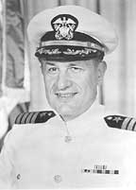
John Clarkson Dowling’s
Career

Birthdate: November 14, 1920 in Strawn, Texas
Education: Undergraduate degree from the University of Colorado; PhD from the University of Wisconsin (’50). Graduate of the Navy Japanese Language School, Boulder, Colorado.
Experience: Lt. Commander (retired), The United States Naval Reserve; Dean Emeritus of the Graduate School, 1979–1989; the University of Georgia Alumni Foundations’ Distinguished Professor of Romance Languages (1992); Department Chair at Texas Tech
University, Lubbock; Indiana University, Bloomington; The University of Georgia; Graduate
Programs Initiated: mass communications, musical arts, social work, historic preservation, agricultural economics and artificial intelligence.
Honors & Awards: Festschrift,
Studies in Honor of John Clarkson Dowling (1985); Guggenheim Fellowship (1959–60); Corresponding member of the Hispanic Society of America; Directed National Defense Education Act Summer Language Institute and a National Endowment for the Humanities Summer Seminar.
Books and Publications:
Dowling’s publishing experience is extensive. During the years 1957 to 1977, he published four scholarly books in the Spanish language. He authored seven editions of literary texts between 1967 and 1982. From 1952 to 1982, Dowling wrote 48 articles of research and criticism and contributed 38 book reviews which were published here and abroad. In addition, he wrote 18 miscellaneous publications, contributed seven articles to The
Scriblerian, and produced another 10 abstract and research reports. (fin)
University of Georgia
Graduate School Magazine
Winter 2007
Pp. 20-23
_______________

CPT Wendell J. Furnas
Class of 1934
One of three sons of Edgar A. and Dottie Scoggins Furnas, Wendell’s life can best be described as one adventure after another. Dottie died when the children were small, so the boys were sent to live with grandparents in Peabody, Kansas.
In Kansas at that time a drivers license could be had for 50 cents, so at age 14 Wendell and brother Bob (Class of 1933) bought a Model T Ford for $20 and went west to live with Dad, who had moved to Santa Paula to be the parts manager for Ed Lawrence Ford Motor Co. The boys got as far as Albuquerque, New Mexico, sleeping alongside the road and eating what they could find. They awoke in the morning to find their car with three flat tires and a sick engine. They sold their car to a passing motorist and hopped a freight train for passage back to Kansas.
By 1934 Wendell managed to get to Santa Paula to live with Dad and his new wife Myrtie Hutchins Furnas. He completed his education at SPUHS and was an active member of the “Epworth League” of the Methodist Church. His best friends, all being members of this group, were Reola Maland, Loren Ayers (‘27), Jack Imhoff (‘32), and the Hyde children - Elmer (‘26), Charles (‘35), Gladys, and Esther (‘29) who later became his wife. (See a previous biography of Esther Hyde Furnas.)
Following graduation from SPUHS Wendell attended Ventura Junior College, where he was later honored as an outstanding graduate. He then packed his worldly possessions into his Model A Ford and headed for the University of California, Berkeley. Here he graduated cum laude with a degree in English Literature and History.
Wendell then accepted a teaching position at the Shanghai American School in Shanghai, China. While there he visited with Dee Davis (‘35), who was then vice consul to the U.S. in Nagasaki, Japan.
In the spring of 1940, Americans were advised to leave Shanghai because of deteriorating relations with Japan. This closed the Shanghai School, so Wendell transferred to St. John’s University as an English professor. Simultaneously he worked as an editor for two Chinese/American language newspapers.
By this time Shanghai was shelled, a British gunboat was sunk, and the city was taken over by the Japanese. Wendell now attempted to leave the country and traveled under cover of night with a band of escaped Marines and others led by guerrillas. After four days of travel they were captured by the Japanese Army. They were sent to the Bridge House Prison in Shanghai, where they were interrogated and tortured and some were put to death. While there, the crew of a Doolittle Raiders bomber was incarcerated and before the war ended two were executed and two died of malnutrition. When released, after being sentenced to death, Wendell brought back the names and some photographs he had taken and, as a result, is mentioned in the book “Thirty Seconds Over Tokyo.” Eventually Wendell was traded for a Japanese in the U.S. who was wanted badly by Japan.
Because of his connections with the Swiss Consul, Wendell was deemed the “luckiest man in China” and was sent home on the Swedish ship Gripsholm in the first personnel exchange. When he arrived in Washington, D.C. he joined the Navy as a Japanese language student, and completed a 15-month study to become a translator for Japanese prisoners.
Wendell worked in Admiral Nimitz’s Intelligence Center in Pearl Harbor, and joined the Marines on Guadalcanal. He served on an amphibious staff which took the first troops into Korea at the end of World War II, and contributed to the translation of the Japanese hydro charts for the Japanese mandated islands. He served in the U.S. Navy for 30 years, was on the CINCPAC staff, a commandant of the Defense Intelligence School, and served in numerous intelligence areas of the Navy.
Wendell’s life has covered the positions of Naval officer, author, educator, world traveler, and Santa Paula citrus grower. Space prevents us from telling his full story, and we can all hope that he will write and publish his autobiography so we can all read the various chapters of this exciting life of a Santa Paula Union High School Alumnus.
By B.J. Harding
Santa Paula High School
May 11, 2001
___________________
Edmund A. Leonard
OLS 1946
1919-2008

Edmund Albert Leonard, scientist and professor, Brewster, Mass., died on March 1, 2008. Born in the Bronx on April 5, 1919, Leonard grew up in Yonkers, where he graduated from Gorton H.S. as valedictorian. He attended the College on scholarship, majoring in chemical engineering, and earned an M.A. in chemical engineering in 1948 from the Engineering School.
While serving in the Navy as a lieutenant, Leonard attended the Japanese Language School at the University of Colorado. He became fluent, and following his service as a translator returned to New York, where he was a chemist for Alexander Smith Carpets. He worked for General Foods from 1956–84, where he became chief scientist, and was an adjunct professor of food science at Cornell; he authored textbooks on packaging. Leonard was the president of the Packaging Institute and was active in the World Trade Organization and the United Nations Industrial Development Organization. He traveled throughout the world and was an avid stamp collector. Leonard was a member of Christ Church Episcopal since 1993 and was an usher. He was predeceased by his wife, Aileen, and is survived by his sons, Donald, and his wife, Lorraine, and Kenneth, and his wife, Janet; daughter, Gwendolyn; and three grandchildren.

Columbia College Today
September/October, 2008
_______________

Japanese American Redress Activist
Tsuyako 'Sox' Kitashima
Dies

She was a diminutive lady, yet a passionate and emotional force who became the grassroots face of the Japanese American Redress Movement.
Tsuyako "Sox" Kitashima, a community icon who helped countless numbers of Japanese Americans gain redress from the U.S. government for their wartime incarceration in concentration camps, passed away on Dec. 29, 2005 of an apparent heart attack at a San Francisco care home.

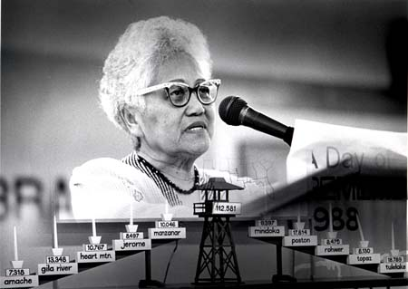

photo by Isago Isao Tanaka

San Francisco Public Defender Jeff Adachi, who called Kitashima "an incredible friend and mentor," last saw Kitashima on Christmas Eve. She was "in good spirits" and "looked well," he said.
"She was a woman of action," added Adachi. "She liked to talk, and was very articulate about her passions, but her actions defined her."
"Sox was one of a kind," added Carole Hayashino, herself a Japanese American redress activist who now serves as a vice president at California State University, Sacramento. "I often referred to her as the "Godmother of Japantown" because she looked over so many of us. But her influence went beyond San Francisco's Japantown.
"She inspired us with her intense passion for justice during the redress campaign and her unconditional love for the community as a daily volunteer for Kimochi and JCCCNC (Japanese Cultural and Community Center of Northern California)," added Hayashino.
Kitashima had been in Ada"s Care Home in San Francisco"s Richmond District from Jan. 2, 2004.
The beloved Nisei, whose impassioned pleas for justice won over the hearts and minds of so many, was recognized far and wide with various local and national awards and honors. (to be cont’d)
Kenji G. Taguma
Nichi Bei Times
January 12, 2006

[Ed. Note: Among others, Ms. Kitashima assisted the kin of JLS Sensei in their request for redress. So I thought I would include her story.]
_______________

Reprise on
Takejiro Higa & 90 Day Wonders
[I just knew that 2008 interview with MIS veteran, Takejiro Higa, in Issue #132, would elicit responses. This came in late January 2009] I wish to share with you some impressions I have of Takejiro Higa.
While in Japan as a missionary kid I went to a Japanese school before the war and continue to speak Japanese as a native, however, my wife thinks my English is slipping. I talk with a kantō accent and still enjoy Japanese news and drama programs on TV from the Los Angeles area.
When I went to Camp Savage some 66 years ago (that probably was where Takejiro went to Military Language School) there were three general groups of Japanese American recruits who attended. Those from Hawaii who really liked to play but were very poor in Japanese and English, those from the mainland who were divided into two groups, ones who never went to Japan but attended doyō gakkō (Saturday school) to study Japanese and the kibei who got their Japanese education in Japan.
Of these three groups Takejiro fell into the poorest group of Japanese and English speakers. I wonder if he could tell the difference in dialect from those in Okinawa and say Kagoshima, Osaka, Tokyo or Tsugaru, all located in Japan proper. I bet he can't even sing kimigayo, the national anthem.
One other correction. When speaking about the instructors at his school, he said, "Oh, they're all Japan University grads. Kibei nisei." At Camp Savage that was not the case. However, they all spoke perfect Japanese and instructed very well.
I agree that some of the Caucasian graduates could not speak Japanese very well even after graduation and a commission. However, they were not ninety day wonders, as he put it. They were 180 day wonders, twice the time. Would that make them twice as good?
I never met Takejiro in the Philippines, I was with the Sixth Army when we landed in Luzon and worked with Gen. Kreuger and his staff as an interpreter, and I interrogated many Japanese prisoners, including Gen. Yamashita in the Philippines after the war.
So much for Higa.
Baldwin T. Eckel
US Army JLS
PS: The biggest tragedy was that those Japanese Americans who graduated from USAMIS did not get a commission. Terrible injustice.
BTE
[Ed. Note: I included the Takejiro Higa interview in #132 for its comments on Donald Keene. But truth be known, there have been critics of Army, Navy and Marine JLO language skills, many from within the program from other graduates. I suppose a 14 month program has its limitations and not every student had the benefit of a childhood in Japan, not even the Nisei. Meaning no disrespect to Mr. Higa, I figured I should at least allow the Army 180 day wonders to speak on their own behalf (having been a standard issue ROTC USAR officer myself, whose field artillery knowledge probably never reached the skill level of the Japanese all of you spoke. Splash, Over]
_______________

Donald N. Carman
1922 — 2008
OLS 4/11/45-
Donald Newton Carman was born in Shanghai, China, to missionary parents, the Rev. Newton H. Carman and Mildred S. Carman, M.D. (nee Mildred Alice Scott).
As a child he lived in Illinois, Iowa, California and South Dakota before moving to Corvallis in 1939. He served during World War II as a language specialist for the U.S. Navy. He briefly taught mathematics at Oregon State College both before and after the war.
He married Kathrine Jensen on March 6, 1948, in Chicago. In 1950, they returned to Corvallis, where he worked for the U.S. Postal Service for many years.
Donald had an overall love of learning and interests and hobbies too numerous to list. After retiring in 1979, he and Kathrine traveled frequently, to Europe, South and Central America, Hawaii, and throughout the United States, as well as to Mexico and Canada. His interests were reflected in his large library, including many beautiful editions of Omar Kayyam’s “Rubaiyat”and Lewis Carroll’s “Alice in Wonderland.” He had copies of these books in several languages.
Donald minored in languages and spoke Chinese as his first language in China, which he learned in part from amahs while his mother was busy as the sole doctor at the mission in Swatow.
He was interested in decorating his home with art, some of which were his own creations. He also had a positive love of animals and especially loved cats.
Survivors include his wife, Kathrine, of Corvallis; son, Frederick of Hillsboro; daughter, Patricia Mueggler of Portland; three grandchildren; brother Kenneth Carman of Salina, Kan.; and sister Cynthia Wallace of Elbridge, N.Y.

Corvallis Gazette Times
January 1, 2009

Donald N. Carman passed away December 30, 2008.
We met in the music library on the campus of Oklahoma A&M University in Stillwater. After graduating, I moved to Chicago. He returned to Oregon to finish his degree. We were married in Chicago and returned to Corvallis.
We had a long and happy life together. We celebrated our 60th Anniversary in March, 2008.

Sincerely,
Katherine J. Carman

[Ed. Note: We had a lively correspondence with Mr. Carman from 2006 through 2007. I will miss his commentary.]
_______________

State Department
JLOs

Martin Packman sent me (12/19/08) a copy of Roger Pineau’s incomplete listing of State Department JLO/OLOs, having read the pieces I have written about The USN JLS/OLS contribution to US Diplomacy. I have already written about some Pineau did not find, like Thompson Buchanan. In addition Roger Pineau was not looking for those who attended courses in Chinese, Russian and Malay.

Allen, Harry JLS 1944
Barbier, C. Edward, JLS 1944
Bartz, Carl F., JLS 1944
Battey, Bryan M., OLS 1946
Bavis, William S., OLS 1946
Boorman, Howard L., JLS 1944
Canzoneri, Vincent, JLS 1944
Cory, Ralph Prewar JLS
Costolanski, Paul J., OLS 1946
Cross, Charles T., JLS 1943
Curl, Richard E., JLS 1944
Dawson, Francis, JLS 1944
Dornheim, Arthur R., JLS 1943
Dudoff, Harold S., JLS 1944
Dur, Philip F., JLS 1944
Farrior, John M., JLS 1944
Few, Lyne S., JLS 1944
Finn, Richard B., JLS 1943
Frankel, Charles, JLS 1944
Gard, Richard A., Hawaii JLS 1941
Green, Marshall, JLS 1943
Hirschritt, Ralph, JLS 1944
Hubbell, Robert L., JLS 1944
Jacobson, Harold, JLS 1943
Jones, Carl N., JLS 1944
Jones, William G., JLS 1944
Kroll, Ernest, Harvard JLS 1942
Lacey, John A., JLS 1944
Lamott, Kenneth C., JLS 1944
Levin, Harold A., JLS 1944
Manhard, Philip W., JLS 1944
Mayer, Jean, JLS 1944
Meloy, Daniel J., JLS 1944
Mendel, Douglas H., JLS 1944
Murfin, Thomas H., JLS 1944
Nelson, Carl J., JLS 1943
Nichols, Walter, JLS 1942
Olson, Lawrence A., JLS 1943
Osborn, David L., JLS 1943
Packman, Martin, JLS 1943
Petree, Richard W., OLS 1946
Pineau, Roger, JLS 1943
Pisanko, Henry J., OLS 1945
Sebald, Wiliam J., Tokyo JLS 1928
Seidensticker, E.G., JLS 1943
Sherman, William C., OLS 1946
Spiers, Ronald I., OLS 1946
Springsteen, George S., OLS 1946
Sultan, Herbert L., JLS 1944
Tucker, Simon, OLS 1945
Wade, Robert H. B., JLS 1943
Wagner, Warren H., JLS 1943
Wald, Royal J., JLS 1953
Wilbur,Halsey H., JLS 1943
Wonder, Charles W., JLS 1944
Zurhellen, J. Owen II, JLS 1943

David M. Hays
Editor & Archivist
_______________

$Donations Received

The Archives has recently received generous donations from:

