The US Navy Japanese/Oriental Language School Archival Project

The Interpreter
Archives, University of Colorado at Boulder Libraries

Number 179 Remember September 11, 2001 | arv@colorado.edu January 1, 2013

Our Mission

In the Spring of 2000, the Archives continued the original efforts of Captain Roger Pineau and William Hudson, and the Archives first attempts in 1992, to gather the papers, letters, photographs, and records of graduates of the US Navy Japanese/ Oriental Language School, University of Colorado at Boulder, 1942-1946. We assemble these papers in recognition of the contributions made by JLS/OLS instructors and graduates to the War effort in the Pacific and the Cold War, to the creation of East Asian language programs across the country, and to the development of Japanese-American cultural reconciliation programs after World War II.

Memoirs
Of Ari Inouye

(Cont’d) Upon Howard Gilkey’s retirement, I worked for Ned Rucker, who succeeded him. I was asked to design garden displays for the Domoto Nursery in Hayward, and I designed a garden along with “Muzzy” Kimura for the San Mateo Garden Festival, and for the Marin County Garden Show in Ross. After I started working for the University of California in Berkeley, I was asked to be a judge at all of these major Garden Shows in Oakland, San Mateo, Ross and at the Alameda County Fair in Pleasanton, where they also had a Home and Garden Show. I continued to serve in this capacity for years to come.
One spring day in 1948, I received a call from Professor Vaughn, my former professor in Landscape Architecture. He was recommending me for a position with the Office of Architects and Engineers on the Berkeley campus; it involved expediting and designing some of the landscaping projects primarily on the Berkeley and Davis campuses. The work, however, also involved the various field stations such as the Mt. Hamilton Observatory in San Jose, and consulting work for the San Francisco Medical Center and various other UC Campuses, none of which had landscape architects at the time.
The person at the Office of Architects and Engineers who hired me was an architect named Norman Jensen. He was a lieutenant commander on a cruiser in the South Pacific during World War II. His ship was sunk by a Japanese torpedo, and he was in the cold water before he was finally rescued. In spite of his wartime experience, he doubled my starting salary to $400.00 a month. Perhaps by today’s standards it is not a lot, but it was certainly greatly appreciated. The Navy was paying instructors such as myself $200.00 a month*. I supported my family on this salary during the four years we were in Boulder. However, in spite of the small income, we were still able to afford to have some of the Navy students over to the house for a Japanese dinner.
After about three years, the post-war building program for the most part came to a close. In May of 1950, I was offered a position as the Landscape Architect for UC Berkeley’s Department of Grounds and Buildings. The work involved refurbishing the campus grounds that were sorely neglected during the war years. I thought this would be a real challenge and an opportunity to further beautify the campus grounds. My job was to oversee not only the work and maintenance of existing grounds but also all the changes that were taking place throughout the entire campus as new buildings were built or added. In addition, I served as a liaison between the architects, engineers, and the contractors and served on the Campus Landscape Committee. I retired in 1979, having spent 32 years with the University serving as the Campus Landscape Architect, including five years as a consultant after my retirement. It was during my retirement that I redesigned the Alumni House Garden, and restored, moved, and installed the Japanese lanterns to where they are now. Two Japanese stone lanterns and a group of twenty-six stepping stones, a gift of the Japanese Alumni Association in 1934, were originally installed in the Strawberry Creek Area in 1935. When the smaller lantern was vandalized during World War II, the pair was removed from the creek and placed in storage. Finally in 1980, forty-five years later, they were restored and relocated to the Alumni House Garden. (to be cont’d)
Ari Inouye
USN JLS Sensei
1942-1946

[Ed. Note: *Actually, the University of Colorado had the Navy contract and paid their standard instructor salary to the sensei, depending on their academic rank. Senior instructors and assistant professors received more. All beginning instructors in all languages (even in preexisting academic programs) received the same rates, according to the Regents salary lists.]
_______________

Donald S. Willis
1917- 2009

Dr. Donald Sigurdson Willis passed away on August 16, 2009 at the Frasier Meadows Health Center at the age of 92.
Don was born in Astoria, Oregon on June 16, 1917 to Arza and Anna (Sigurdson) Willis. He was the eldest of five children and spent his formative years growing up in the Northwest (Oregon and Washington). He graduated from Roosevelt H. S. in Seattle in 1934 and then joined the Army, serving from 1935-38. After leaving the service he entered the University of Washington graduating with his B.A in 1943. His postsecondary education was interrupted with his entry into the Navy, having served from 1942-45. During this period (Dec.1942), upon moving to Boulder, Colorado to attend the U.S. Naval Japanese Language School, he married Mary Jean Kerr.
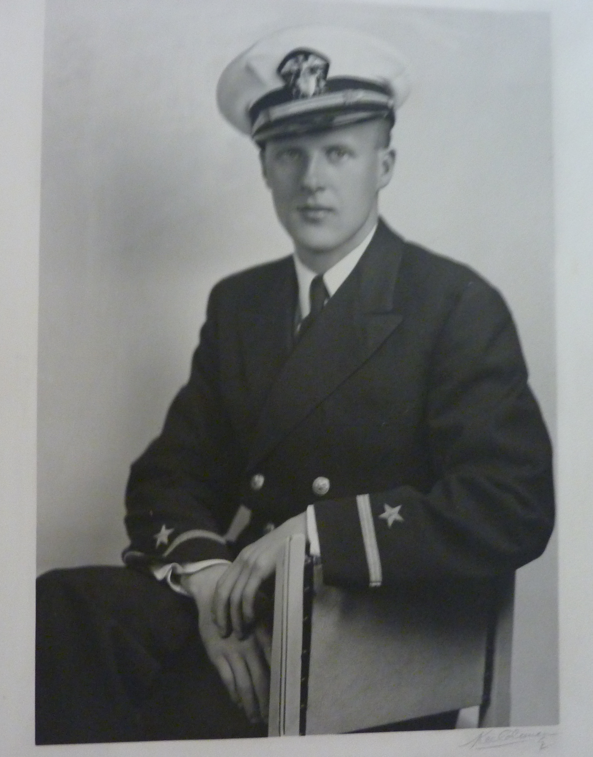

ENS Donald Willis, 1944

Don saw action in the Pacific Theater during the final years of World War II in the capacity of an interrogator/interpreter of Japanese prisoners. Upon separating from the Service, he returned to his graduate studies at the University of Washington in 1946. After completing his Doctorate degree, he was offered a position as Assistant Professor of Oriental Languages at the University of Oregon. In 1962 Don accepted a position as chairman and tenured professor of the new department of Slavic and Eastern Languages at the University of Colorado. He served in various capacities there until his retirement in 1982.
After retirement, Don continued to work on his project of many years; a reference document of “Japanese Names”. He completed this work in 2002 and it will be donated to the Archives at the University of Colorado.
Don is survived by a daughter, Carol and son, Rick as well as four grand-daughters and two great grand-daughters. He was preceded in death by his wife, Mary Jean and son Randy.
At Don’s request, there was no service. A private family memorial followed.
Richard Willis

[Ed Note: Professor Willis was a long-time chair of the University of Colorado’s Oriental Languages Department in the 1960s and 70s, as well as having participated actively in the USN JLS/OLS Archival Project, both during the 60th Anniversary Reunion in 2002, the Veteran’s Day dedication of the JLS/OLS Plaque, and the 2008 JLS Tour of UCB, given to the attendees of the Japanese American National Museum Denver Convention. We will miss him.]
_______________

The Reminiscences of
Donald Sigurdson Willis

[Donald S. Willis passed in 2009. This is an excerpt of a longer memoir.]

The US Naval Japanese Language School (1942-43)

[Cont’d, at Boulder] Mary Jean’s father and mother came to the wedding, and my brother Ray was my best man. We were married in the first Congregational Church, with quite a number of language students in attendance. Tom Kaasa played the organ. After the reception, we went down to the bus station, and were lucky enough to get seats to Colorado Springs for our wedding trip. My section gave me Glück’s Orphée as a wedding present, and this was what I heard in my “inner ear” as the bus rolled along. We visited the Garden of the Gods, and had a good time in “the Springs”.
It was not long before we discovered Boulder’s best kept secret: 100 MPH winds! The French doors of the apartment opened directly west, and the trumpeting set up by the blasts was enough to bring Louie running with a 2x4 to nail across the doors to keep them from blowing open.
We all smoked (or almost all), and I even developed a taste for cigars soaked in crème de menthe! I was also fond of loganberry wine. Mary Jean would walk down to Arapahoe and Broadway, at the bottom of the hill, and walk home carrying two large sacks of groceries bought in the Safeway store there.
One fine spring day, I thought I would like to go fishing up Boulder Creek a little way, but I didn’t have any tackle. So I made a pole from a tree branch, bought a hook and line at Woolworth’s “Five & Dime” on Pearl Street, found me an angleworm or two, and came back with a trout [Oddly, with all the mine tailings, tungsten, mercury, cyanide, radium, and chlorine mill waste, and oil, gasoline, and street refuse that goes into Boulder Creek, the stream still supports Rainbow and Brown Trout.]
Our class was commissioned after graduation. Succeeding classes were commissioned at the outset, and could build up seniority in rank while in school, a real break! We were given the choice of Navy or Marines. Dick Greenwood and Earl Swisher (who taught Chinese history at CU) chose the latter, along with a number of others. The majority stayed with the Navy.
We were very busy at the end, getting fitted out for our uniforms, and also getting our book boxes built – to carry our tools, so to speak, the many dictionaries and handbooks the Navy supplied us with for reference. (It goes without saying that most of them found a watery grave!). I still have smaller dictionaries which I had bound on campus with leather from one of MJ’s discarded purses. (to be cont’d)
Donald S. Willis
JLS 1943
_______________

Thomason, Edwin Nott
Elizabeth, N.J.

Dr. Edwin N. Thomason, 82, Poet Laureate of Kean University, Union, N.J., of 343 Springfield Road, died Aug. 21 at Union Hospital, Union, N.J., after an extended illness.
He was a native of Drayton, and the son of the late Edwin Nott Thomason and Wilma Painter Thomason Francis. He was widower of Lillian Lydia Glauser Thomason, and of the Baptist faith.
Dr. Thomason was a retired Professor at Kean University in Union, N.J. He was a graduate of Spartanburg High School, Wofford College, University of Indiana, Northwestern University and a had a Doctorate Degree from Columbia University.
He was a veteran of the U.S. Navy during World War II [JLS 1944], having served as a Decoder during the Japanese Campaign.
Dr. Thomason is survived by an aunt, Angelina Painter Fowler, of Spartanburg; a sister-in-law, Winfred Thomason, of Spartanburg; a brother-in-law and sister-in-law, Robert and Helena Buchlar, of Monroe, Wis.; and several nieces and nephews. He was predeceased by a brother, John L. Thomason.

The Greenville News
August 24, 2001
_______________

Ruth Webb Sigerson
WAVE, JLS 1944

I was born (1922) and raised in Nashville, Tennessee, graduating in 1938 from the Demonstration School of Peabody College for Teachers, where my father taught chemistry. Thinking me too young at 16 to be cast into a university, my parents sent me off sulking to Stephens College in Missouri, a two-year girls’ school esteemed in the South for taking good care of its girls. To my surprise I enjoyed Stephens, got lots of attention from teachers who hadn’t many academically inclined students, and graduated in 1940 with an A.A. degree and a scholarship to the University of Chicago.
Chicago in those days was all for the Great Books and counted no undergraduate grades except the grade on the final baccalaureate exam. I managed to survive this and graduated in 1943 with a B.A. in English literature and a Phi Beta Kappa key. I didn’t know until years later that the young “metallurgists” I sometimes met at campus events were actually members of Enrico Fermi’s atom bomb development team.
Back in Nashville I applied for WAVE officer training but failed the math and mechanics part of the entrance test. I was about to return to a promised job with the Encyclopedia Britannica in Chicago when I received my first Phi Beta Kappa newsletter, with Cdr. Hindmarsh’s call for recruits to the Navy Japanese Language School. I’d never thought of studying Japanese, but it seemed a heaven-sent opportunity to bypass mathematics and get into the Navy. I instantly applied and eventually got to Boulder in the fall of 1943 as one of the last class of WAVE language students.
I thoroughly enjoyed my stay at the Language School; it seemed almost indecent to be leading such a satisfying life in the midst of a savage war. I never did develop the real feeling for Japanese that I envied in some of my classmates, but found it not too hard to do what was expected of me (except for a total inability to write decent kanji with my left hand).
I was lucky in my roommate, Adele Rich (later Jaworek), a wiry dynamo whose mental and physical energy were matched by her generosity of spirit. She found me a pale bookworm and set out to turn me into an outdoorswoman worthy of the Boulder scene, sweeping me into mountain hiking, horseback riding, even ice skating. Some of my best memories are of morning rides in Eldorado Springs with meadowlarks singing all around, and long hikes over the shoulder of Flagstaff to have a meal at Blanchard’s in the canyon.
I couldn’t list all the human friends I came to value deeply, but I must mention Heidi, the 165-pound St. Bernard we inherited from the Phi Delts, who cane to be the guardian spirit of the house. Amazingly gentle for such a huge dog, she was unfailingly affectionate to all of us, and loved to accompany us everywhere, even though we once brought her back from a too-long hike with bleeding paws. The dining room cooks gave us daily leftovers to feed her—once, I recall, a whole pail-full of T-bone steaks with gravy.
Some of you will remember that I met Bill Sigerson on a blind date in March 1944 and married him six weeks later in the little Episcopal Church downtown. It was an uncharacteristically rash act for both of us, but luckily we have never regretted it.
Soon after the wedding Bill went off to Pearl Harbor and eventually to Saipan. I finished the course and was assigned to the Stuart Building in Washington, D.C., where I spent the rest of the war. About all we did in the office where I worked was to translate miscellaneous documents shipped back from the Pacific. None seemed especially useful—I once spent several weeks on a student’s notebook from an elementary meteorology course—and most of us assumed we were just being kept in practice pending the invasion of Japan. When the war ended and Bill returned to Washington I was ready to leave.
My only real achievement in Washington was to secure a first class brother-in-law. Bill and I brought my sister Mary (then working for the Army Signal Corps) to a large JLS farewell party where we introduced her to Neal Jensen. They were married in Washington a few months later, and now live near us in Albuquerque.
Since Bill had his law degree and New York Bar admission before entering the Navy, we settled down to a series of legal jobs in New York City, ending up in a pharmaceutical firm where he came to specialize in foreign contract negotiations. Like all good Baby Boom couples we lived in the suburbs—Larchmont, N.Y., where Marilyn was born in 1948 and John in 1951, and later in New Jersey, first Westfield, where we bought a house from JLS friends Bill and Mary Jane Carroll, then Chatham, where we lived for 31 years.
I stayed at home with the kids until the early ‘60s, when the Feminine Mystique malaise hit me about the same time it did Betty Friedan and drove me back to college. I took a M.L.S. degree in library service from Rutgers in 1963 and found a job as a cataloger at the Chatham Public Library which I kept for the next 22 years. Though miserably paid, it was perfectly suited to my interests, talents, and shortcomings, and I have never tired of it. Probably the most useful thing I ever did for other people in my life was to help organize a union at the library and negotiate a contract giving health insurance and pro-rated pensions and benefits to our part-time employees, some of whom had worked 20 or more hours a week for years with no benefits whatever.
Growing up in the turbulent ‘60s, our two children made some career and lifestyle choices I’d just as soon forget, but they have now settled down into respectable middle age. John and his wife are writers who live in the Washington area, and Marilyn, married to a Mexican Nisei who is in the shipping business, lives in Cuernavaca, Mexico. She and Naruo earlier lived for 7 years in Japan, where she got a master’s degree from Sophia University and acquired a genuine fluency in Japanese. Their two little boys, aged 7 and 5, speak Spanish at home, English reasonably well at school and with their grandparents, but haven’t yet taken up Japanese.
Bill and I both retired in the mid-‘80s and moved to Albuquerque in 1989, to be near the Jensens, to escape the northeastern winters, and to stimulate our minds with a new and different landscape and culture [Sadly, since 1993, Bill Sigerson, and the Jensens have passed, as well.].

Ruth Webb Sigerson
Story taken from the
1993 WAVE Reunion Book
_______________

Distinguished Alumni
Roy P. Fairfield, Class of 1936
1997 Recipient, Humanities

The Alumni Association honors Roy Fairfield [OLS 1945] as a historian, author, and educator. In each of these fields he has made distinguished contributions. He may justly be called Saco's historian, being the author of two books on Saco history–Sands, Spindles and Steeples and New Compass Points. He is also the editor of Humanistic Frontiers in American Education, Humanizing the Workplace, and an edition of the Federalist Papers. On the creative front, he is the author of two novels, three books of poetry, and a collection of modern fables. After obtaining his doctorate from Harvard, Mr. Fairfield taught at Bates College, Ohio University, Athens College in Greece as a Fulbright Professor, and Antioch University. In 1970 he co-founded the Union Graduate School, which has become one of higher education's major innovations as a university without walls. To date over 3,000 students have earned their doctorate degrees working with a committee of professors drawn from universities across the nation. He personally has served on over 600 doctoral committees. Mr. Fairfield also served as the founding president of the Buckeye Trail, a 1,200-mile hiking and biking trail created in Ohio. For all his worldly accomplishments, he is proud of the fact that he also served as Thornton Academy's first trainer-manager of the football team.

Thornton Academy
Saco, Maine
_______________

Columbia Celebrated
50 Years of
Asia Studies
[Now 60]

Fifty years ago [60, now], only a handful of American universities taught courses for undergraduates on Asia and none offered a broad-based general education on Asian civilizations. Most courses on Asia were highly specialized, dominated by classical language study at the graduate level.
Today, there is hardly a college campus in the country that does not offer some undergraduate courses on Asian humanities and civilizations. On May 7, Columbia University celebrated the pioneering initiatives of its faculty following World War II in developing general education courses on Asia to add to its renowned undergraduate Core Curriculum on Western civilization.
As the first college in the
country to develop a broad-based study program on Asia for undergraduates, Columbia’s leadership and excellence has long been recognized as the spark for programs elsewhere.
In the fall of 1948, Professors Moses Hadas of the Greek and Latin faculty and Herbert Deane, a political scientist, were the first to teach what was then called the Oriental Colloquium. This course was followed in 1949 by Oriental Humanities and a year later by Oriental Civilizations.
“The fact that the early instructors were not specialists in Asia demonstrates the willingness of scholars in those days to venture beyond their own fields,” says Columbia Professor Wm. Theodore deBary, one of the foremost scholars of Asian humanities who for many years guided Columbia’s Asia humanities and civilizations program.
The general study of Asian humanities was so new then in the West that source materials in English for reading and discussion were almost non-existent, said deBary, who with support from the Carnegie Corporation translated original source material and wrote a series of books for use in the Columbia Asia courses: Sources of Japanese Tradition (1958); Sources of Chinese Tradition (1960) and Sources of Indian Tradition (1960).
Professors Donald Keene and Burton Watson were major contributors to the series, which to date includes more than 150 titles for use in general education on Asia. It is now supplemented by Sources of Korean Tradition and by Translations from the Oriental Classics. For many years, the Sources books have been top sellers for Columbia University Press.
During the 1960’s courses were added on Asian music and art. Today, Columbia offers undergraduates a sequence of one-year courses on the civilizations and major texts representing the four major Asian traditions: Middle Eastern, Indian, Chinese and Japanese.
Through the 1990’s, the University Committee on Asia and the Middle East has been engaged in a major revision and expansion of the Sources books, now six volumes in all, as well as the completion of Volume II of Sources of Korean Tradition.
Many students who enrolled in Columbia’s early Asian humanities programs and who went on to become leading specialists in this field will participate in the day-long 50th anniversary convocation for Asian humanities and civilizations.
Several dozen professors, instructors and students past and present spent the day on campus recalling the beginnings of Asian humanities and civilization courses at Columbia and discussing the state of Asian studies today.
Organized by deBary and Irene Bloom, chair of the University Committee on Asia and the Middle East, the convocation brought together other major academic figures in the field, including Donald Keene and Ainslie Embree, professors emeritus of Columbia, and Robert Goldman of the University of California at Berkeley and John C. Campbell of the University of Michigan.
Many students who participated in the program have gone on to distinguished careers in academia, business, public affairs and other fields, including Kenneth Lipper, Chairman, Lipper & Co. and former Deputy Mayor of New York City; Philip Milstein, President, Emigrant Savings Bank and Columbia Trustee; Morton Halperin, Director of Policy Planning, U.S. State Department, and Norman Podhoretz, Editor-at-Large, Commentary Magazine, who was a student in the first Oriental Colloquium.
DeBary, who at age 79 continues to teach Columbia undergraduates as a member of the Society of Senior Scholars, said faculty in Columbia’s Core Curriculum foresaw the need to include Asia as early as the mid-1930s. “Though in the minds of many Asia only came into focus after World War II, the implementation of this early vision at Columbia was actually interrupted by the war,” said deBary.
“It was the outgrowth of an educational vision that went beyond their own academic specialities,” said deBary of the pioneers of Asian studies. “They thought of themselves as responsible, not only for scholarship in their own fields, but for the overall education of young people, at a formative stage in their lives, as citizens and more broadly as human beings.”
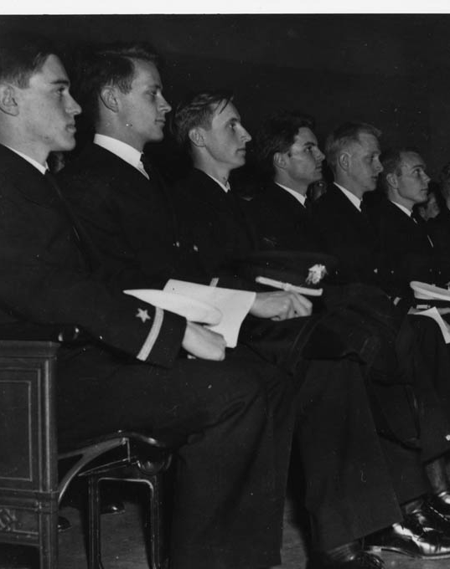

Ensigns Keene, Osborn, deBary, Turner, Allman & Brock, 13 January 1943 Graduation, US Navy JLS, Univ. of Colorado, Pineau, 06_04_01_10, AUCBL

DeBary’s own interest in Asia began as an undergraduate at Columbia, where he took up the study of Chinese. He continued his studies at Harvard in 1941. With the outbreak of World War II, he was commissioned in the Navy and attended Japanese language school. He went oversees in 1943 as a Naval intelligence officer and was stationed with Admiral Chester Nimitz’ Pacific headquarters staff. After the war, he earned a doctorate and returned to Columbia where he was put in charge of designing undergraduate education in Asian studies.

Suzanne Trimel
Columbia University News
May 18, 1999

[Ed. Note: Found this 10 year old article on the web and thought it would be good to highlight Professors deBary and Keene, while at the same time recognizing the 60th year of Columbia’s Asian Studies. I included this Pineau Collection photo that shows, not only Professors deBary and Keene, but also: David L. Osborn, linguist and diplomat; Frank L. Turner, soon to be assigned to FRUPAC; William H. Allman, who served on Okinawa; and Sam H. Brock, translator turned oral surgeon after the War. The seats these guys sat in are now used at the Chautauqua Auditorium, traded out when Macky Auditorium was renovated in the 1980s. ]
_______________

COL HARRY PRATT
USMC (Ret.)
IS THE RECIPIENT OF THE
2007 [WINE COUNTRY]
SEMPER FIDELIS AWARD
Each year, a [The Wine Country Marines] Birthday Ball Planning Committee made up of approximately 40 people does the real work behind the scenes to ensure a successful and enjoyable event each November. Several members of the group are also actively involved in our other activities throughout the year to include our three non-profit charities: Devil Pups, Injured Marine Semper Fi Fund and Toys For Tots. When Marines decide to do something, they tend to really get the job done right. However, someone often goes above and beyond the call of duty and it is only fitting to recognize this type of dedication and hard work. Colonel Warren Jaycox initiated this award and here is what he had to say regarding the 2007 recipient:
"In testimony and tribute to outstanding contributions and exceptional accomplishments as co-founder of the Wine Country Marines and the Wine Country Marine Corps Birthday Ball, the Wine Country Marines takes pleasure in awarding the 2007 "Semper Fidelis" Award to Colonel Harry Pratt, USMC (Retired)."
"Colonel Harry Pratt has always been there when needed. "I'll take care of that," and "It's been done," and "What else can I do" were indicative of his attitude and support. He has almost 100% attendance at any Wine Country Marine event and he is a significant reason that the Wine Country Marine Corps Birthday Ball has continued all these years and has enjoyed increasing success. I could add pages of glorious statements attesting to his dedication and long and illustrious service in the Corps, but this award is not to emphasize that career, but to recognize the service he has given to the Wine Country Marines and its predecessor, the Association of Sonoma Marines. As is the case with many of us who serve in this proud organization, our participation is not a sole endeavor, but one actively and staunchly supported by their spouse. Thus, in recognizing one we recognize the other. Therefore, Grace Pratt rightfully shares this award with her husband."
A native of Los Angeles and a proud UCLA graduate, Colonel Harry Pratt is a retired career Marine who served as a infantry officer during the Second World War in the Pacific. He is a combat veteran of both the Guadalcanal and Tarawa campaigns which were two of the fiercest battles ever fought and won by the U.S. Marine Corps. As one of the very few Marine Officers who could speak and understand the Japanese language, he was handpicked to serve as an official interpreter during the Manila War Crime Trials in the Philippines immediately following the War. During his active duty career, Colonel Pratt [OLS 1945] mostly served forwardly deployed within the Fleet Marine Force where he commanded Marines at every level from Rifle Platoon to Infantry Regiment. Just prior to his retirement from the Corps, he served at the Pentagon during the Cuban Missile Crisis. In civilian life, Colonel Pratt worked for many years as a marketing executive with both Pepsico and RC Cola. He was also a small business owner and a successful entrepreneur.
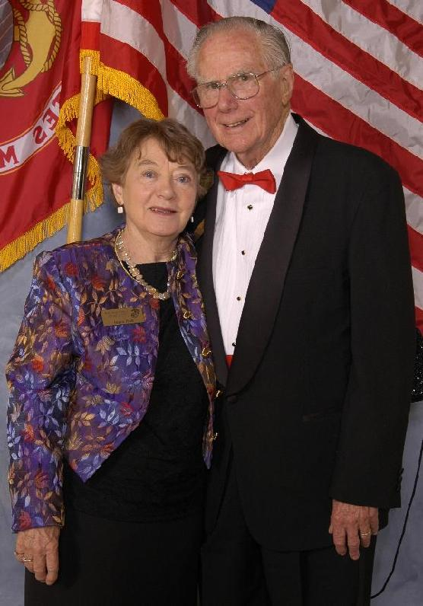

Colonel Harry Pratt and his wife Grace at the Wine Country Marine Corps Birthday Ball (Photo by Chris Berggren of Custom Image Photographic)
Wine Country Marines
http://www.winecountrymarines.com
_______________

