The US Navy Japanese/Oriental Language School Archival Project

The Interpreter
Archives, University of Colorado at Boulder Libraries

Number 217 Remember September 11, 2001 | arv@colorado.edu March 1, 2016

Our Mission

In the Spring of 2000, the Archives continued the original efforts of Captain Roger Pineau and William Hudson, and the Archives first attempts in 1992, to gather the papers, letters, photographs, and records of graduates of the US Navy Japanese/ Oriental Language School, University of Colorado at Boulder, 1942-1946. We assemble these papers in recognition of the contributions made by JLS/OLS instructors and graduates to the War effort in the Pacific and the Cold War, to the creation of East Asian language programs across the country, and to the development of Japanese-American cultural reconciliation programs after World War II.

John H. Rich, Jr. JLS 1943, 96
(1917-2014)

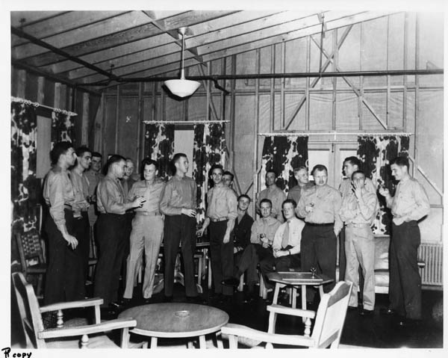
CAPE ELIZABETH -- John Hubbard Rich, Jr., veteran NBC News war correspondent and Maine native, died on Wednesday, five weeks after the death of his wife, Doris Lee, of 60 years. He was 96. Born August 5, 1917, in the summer camp that was built by his father and still stands today on Hannaford Cove in Cape Elizabeth, he grew up in Portland just behind the present-day Ballpark and attended Deering High School ('35) and Bowdoin College ('39). At Bowdoin, he was editor-in-chief of the school paper, president of his fraternity, and captain of the tennis team.
He started his career as a reporter with the Kennebec Journal in Augusta after college and joined the Portland Press Herald about a year later. He got his start as a war correspondent even before the war began when, as a reporter for the Press Herald, he interviewed the survivors of the destroyer USS Reuben James, the first U.S. warship sunk in World War II, five weeks before the Japanese attack on Pearl Harbor.
With the outbreak of the war, he parlayed his college French major into a commission with the U.S. Marine Corps, exchanging French for Japanese, which he learned at the Navy Language School in Boulder, Colo. [Actually the school was located at the University of Colorado, and was one of several classified secret schools at the CU campus during WWII.]

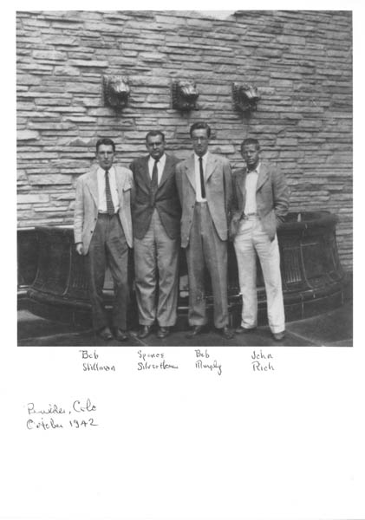

Bob Stillman, Silverthorne, Bob Murphy, and John Rich in Boulder, October 1942, b&w, 5x7, Pineau_27_10_00_13j, AUCBL. [shot taken on the west entrance of Norlin Library. The lion head fountains are still there.]

As a Second Lieutenant with the Fourth Marine Division, he participated in four battle landings in the Pacific, in the bloody amphibious landings at Kwajalein, Saipan, Tinian, and
Iwo Jima. His bravery earned him the Bronze Star. He remained in the Marine Corps Reserve, attaining the rank of Major.
Immediately upon the close of the war in the Pacific, he returned to Japan as a correspondent for the International News Service. He contacted the families of some of his former prisoners of war, traveling on his own to one family, who became lifelong friends, to tell them that the son and husband whom they had buried was alive, in U.S. custody, and would be returning home soon. He covered the International War Crimes Tribunal in Tokyo, interviewed 'Tokyo Rose,' and was once called upon to serve as impromptu interpreter for wartime Prime Minister Gen. Hideki Tojo and his American lawyer.
Under the occupation rule of Gen. Douglas MacArthur, the Emperor of Japan, historically considered divine, was 'encouraged' to go out among his people. More than 40 years later, John wrote for the Boston Globe: “It was mid-February 1946. The Tokyo cold penetrated our war correspondents' uniforms as we waited in the jeeps we had driven from the Foreign Correspondents Club a few blocks away. At precisely 9 a.m. the imperial motorcade snaked slowly out of the trees shrouding the entrance to the inner palace and wound back around itself as it crossed the stone arches of the famous double bridge spanning the moat. First came serious-faced security guards in elaborate uniforms and visor caps riding antique motorcycles with sidecars. Black limousines followed carrying palace officials, and then came Emperor Hirohito in a vehicle with the 16-petal chrysanthemum imperial crest. He looked small, frail and very lonely. Could this be the man Japanese soldiers screamed out as they hurled themselves into our rifle and machine-gun fire on aipan, Tinian and Iwo Jima? I stood 3 feet from this thin-faced monarch with his small mustache and rimless eyeglasses. I could hear him breathing heavily. He was extremely nervous. This was new and precedent-shattering for him.”
From Japan, he covered the Chinese civil war, narrowly escaping Shanghai down the Whangpoo River on a U.S. gunboat as it fell to the communists in 1949. “I've spent 11 years in the Far East altogether. From Saipan to Dien Bien Phu,” he later wrote in an NBC ad in Time. “The Communists nearly caught me when Shanghai fell, but I hitched a ride out with the Navy.” Quipped the ad, “John Rich, you're a pretty lucky fellow.”
Within a week of the North Korean invasion of South Korea on June 25, 1950, he sailed from Japan to Pusan with the 24th Division Artillery and covered the Korean War for the next three years, broadcasting the signing of the armistice at Pan Mun Jom in 1953 for NBC, which he joined six months into the war. In the midst of that arduous war that claimed more than 36,000 American lives, he wrote on Christmas Eve 1952: “The deadly business goes on. Across the front, it's a clear cold night. The light of a half-moon glimmers across the barren frozen hills [and] in damp frontline foxholes, lonesome men [peer] northward, waiting for the enemy.”
Although not a professional photographer, he took almost 1,000 photographs of the Korean War in color, a medium not yet used by mainstream war photographers. This unique color record of the war will this year become part of the permanent collection of the National Museum of Korean Contemporary History in Seoul.
In Seoul, on a tennis court, he met his self-described 'Seoul mate,' Doris Lee, then a secretary with the State Department. They became engaged at the Imperial Hotel in Tokyo and were married, twice in 10 days, first in a religious ceremony in southern France and then in a civil ceremony in Tangier, Morocco.
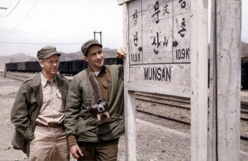

John Rich (l) With Irving R. Levine in Korea during the peace talks.

While starting a family, he covered the French war in Indochina, the 1955 Argentine revolution, making the first radio broadcast from revolutionary headquarters in Mendoza, the violent uprising of the forces of Patrice Lumumba in the Belgium Congo, and the raising of the Iron Curtain in Berlin, where his family of four children, two born in Germany, lived 200 yards from the barbed wire.
A reassignment to Paris proved hardship duty after the outbreak of the Algerian Revolution and the subsequent inhospitality of his miffed French host who temporarily refused to renew his press credentials after a speech at the National Press Club in Washington in January 1961 where he dared to say that France faced the 'very real possibility' of civil war over the Algerian crisis. January 1961 was not lost altogether, however, as that month he bought, for $6,000, Bates Island in Casco Bay, his refuge and great love for the rest of his life.
From France, the family moved to Tokyo where, as NBC's Senior Correspondent in Asia, for more than a decade he covered the war in Vietnam, Laos, and Cambodia and saw all four children graduate from high school. In 1971, he, his NBC colleague Jack Reynolds, and friend and fellow Mainer John Roderick of the Associated Press were allowed into China with the 'Ping Pong Delegation.' He broadcast from Shanghai 22 years after his hasty retreat. A

http://www.tvnewscheck.com/article/75999/veteran-nbc-correspondent-john-h-rich-jr-dies

year later, he accompanied Nixon's trip to China. Following that historic visit, in 1974, he was awarded the Peabody Award, the Overseas Press Club Award for 'Best reporting from Asia in any medium,' and an honorary degree from Bowdoin College at the age of 56.
At his Bowdoin 50th Reunion address in 1989, he said: “My job as a reporter gave me a chance to live in many parts of the world. It made me a realist, but please don't think it made me cynical. All the news is not bad. One simple lesson was driven home to me time after time. When one gets to know people, whatever their background, nationality or racial origin, they are basically alike. Penetrate the surface differences and you learn that they all want about the same things that we do: freedom from want, from fear; freedom to be independent; to have opportunity; to live lives without excessive government interference; a chance to give their children good educations.
I'm reminded of Hong Kong. My wife was riding in a taxicab. “Where are you from?” the driver asked in halting English. “America,” she said. He paused a moment, thought, and then said, “Lucky.””
John and D. Lee lived in the moment. “One of my favorite Japanese haiku has to do with time. The haiku is that unusual form of poetry of only 17 syllables, 5-7-5. It goes like this: 'Oh, so this is all - and she and I had counted on a thousand years.'”
John is survived by his daughter, Barbarine Rich, and her husband, Toshio Okumura, of Boston, Mass., by his son, John H. Rich III, and his wife Joanne Rich, of Falmouth, by his son, Whitney Rich, and his wife Kumiko Umemoto of Tokyo, Japan, by his son, Nathaniel Rich, and his wife Ming Hsu of Hong Kong, China; by his brother-in-law, Ralph Halstead, and his wife Alice Halstead of Hemet, Calif.; and by grandchildren Dylan, Madelaine, Malcolm, Johnny, and Helene.

Portland Press Herald/
Maine Sunday Telegram
Apr. 13, 2014
________________

Spoken with Pride

My father, Kurao Tsuchiya, would have enjoyed reading The Interpreter, as do my wife and myself. He spoke with pride of his days in Boulder contributing to the war effort.
Keep up the good work.

Howard Tsuchiya
Son of Tsuchiya Sensei
________________

Elizabeth Jane Levine
JLS 1944 WAVE
June 7, 1922-May 20, 2014

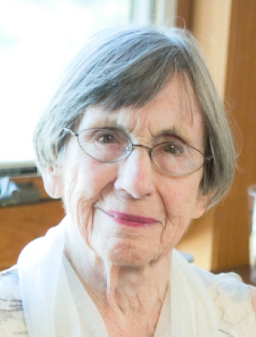

Elizabeth J. "Betty" Levine, 91, née Elizabeth Jane Billett, widow of noted Japanese labor relations expert, Solomon B. Levine, died on May 20, 2014, in Madison, Wisconsin of natural causes.
Born in Lewistown, Pennsylvania, Betty received her BS in chemistry from Pennsylvania State University in 1942, a certificate from the Harvard-Radcliffe Business Program in 1947, and her MA in industrial relations from the University of Illinois in 1965. She met Solomon ("Sol") Levine in 1943, while both were learning Japanese at the Navy Japanese Language School in Boulder, Colorado. They were married while still in the U.S. Navy during WWII.
Betty's professional career began as a Junior Chemist for the Food and Drug Administration from 1942 to 1945. During World War II, she also worked as a translator for military intelligence. After the war, she became the assistant director of the Harvard-Radcliffe Management Training Program from 1947 to 1948. From 1965 to 1969, she served as the Assistant Director of the Institute of Labor and Industrial Relations at the University of Illinois. Betty then worked as the Assistant to the Chairman in the Department of Psychology at the University of Wisconsin-Madison from September 1969 to July 1987 where she was the first non-faculty member to be tenured. At her retirement, a room was named in her honor. Betty was also a passionate activist during the Civil Rights movement, and a volunteer for the Democratic Party.
Interested parties may access a public collection of documents of Sol and Betty at the Univ. of Colorado at http://184.168.105.185/archivegrid/collection/data/492205876. Roger Dingman interviewed them for his book, Deciphering the Rising Sun: Navy and Marine Corps Codebreakers, Translators, and Interpreters in the Pacific War (Naval Institute Press, 2009).
Preceding her in death were her father Irving S. Billett, mother Bertha S. Billett, brother William Billett, and husband Solomon B. Levine.
She is survived by her four children author Jan Levine Thal, musician Samuel B. Levine, composer Michael A. Levine, and Judge Elliott M. Levine; and seven grandchildren, Jeremy Thal, Sean Levine, Sybil Levine, Mariana Barreto, Reed Levine, Joshua Levine, and Zoe Levine.

http://www.informedchoicefunerals.com/obituary/125067/Elizabeth-Levine//

[Ed. Note: The Solomon and Elizabeth Levine Papers were donated to the Archives on July 19, 2000, and is organized, processed and available. Its finding aid can be found on Rocky Mountain Online Archives http://rmoa.unm.edu/. References to the Levines can be found in issues #05, #33, #53, 61a, #68a, #106, #112, #121, #128, #151, #182, and #210. They were active and generous supporters of the project.]
________________

Golden L. Faris
USMC, OLS 5/12/45-

Golden Leslie Faris 89; Indianapolis; passed away June 7, 2011. Born January 8, 1922 in Indian Springs, IN to Golden Wesley and Luna Pearl Lewis Faris. Schooling: Ben Davis HS, Indiana University and the Japanese Language School at University of Colorado and in Stillwater, OK. Golden served in the U.S. Marine Corps in the South Pacific during WWII, survived 4 landings, served as a Japanese translator and received a field commission. He was also a Korean War veteran, became a commanding officer in 1960 and retired a Colonial. Golden's career at the Indianapolis Star began in the mail room and spanned over 50 years between active military duty periods. Golden retired as Production Director in 1996 and was highly sought after as an industry consultant. Golden was a 32-Degree Mason of Lodge 162; Scottish Rite, Fraternal Order of Eagles and Murat Shrine member; Life Member of Military Officers of America and Marine Corps Reserve; and held other significant community roles. In his youth, he was also a successful Golden Gloves fighter. Survivors: Deloris, devoted wife of 69 years; brother, Bob; son, Ron; loving grand- and great-grandchildren. He is preceded in death by son, Edward.

http://flannerbuchanan.tributes.com/show/Golden-Leslie-Faris-91666410
________________

Longtime WSU Dean, Educator, JLS 1944
George Brain dies

PULLMAN, Wash. — George Bernard Brain, the longtime dean of the Washington State University College of Education who influenced public education nationwide, died last week at age 92.
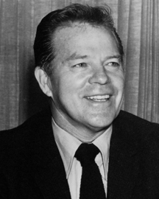

As former colleagues heard the news, they remembered Brain’s formidable recall of people and facts, which strengthened his role as a power broker and passionate educator.
“George knew people all over the country, from the U.S. secretary of education to the superintendents of very small school districts,” said WSU Associate Professor Dennis Ray.
“He just had a phenomenal memory for people and their career paths and for school law, which was his real love,” said Ray, for whom Brain served as doctoral advisor. “In a seminar, he’d bounce off names and dates and court cases. I’m sure if we’d had laptops, we would have been sitting there Googling to see if he was right. He always was.”
Brain was dean of the College of Education from 1965 to 1983. Joanne Harkins was his assistant at the end of his tenure on the Pullman campus.
“He was friendly with everyone, and knew everyone,” said Harkins, now assistant to the dean in the College of Science. “He was from a generation of administrators who actively participated in improving the K-12 schools around the state of Washington by matching principals and superintendents to the right school districts. He really cared.”

A quick rise into
school leadership

Brain was born on April 25, 1919, in the tiny Kittitas County town of Thorp, Wash., where he returned after his retirement from WSU. He died in nearby Ellensburg on July 14.
He is survived by his wife, Harriet, of Ellensburg, son George of Tacoma and daughter Marylou Seeman of Spokane. A private family service will be held Saturday at the I.O.O.F. Cemetery in Ellensburg.
The service will include military honors in recognition of Brain’s service in the Marine Corps during World War II. He was a Japanese language officer and recipient of the Iwo Jima Medal. He was a reservist after the war and wore a Marine Corps baseball cap until his death.
Brain began his career as a teacher in Yakima, but quickly moved into administration. He received his M.A. in education from Central Washington State College in 1950 and his Ph.D. from Columbia University in 1957.
He became the state’s youngest school superintendent in 1953 when he was hired by the Bellevue school district.
In 1959, Time magazine dubbed him “the fastest-rising educator in the U.S. public school system.” It recounted how Brain had put together “a $45 million system of eleven elementary, three junior high and two senior high schools in a community that was little more than a little-red-schoolhouse hamlet before World War II” as well as “some of the most interesting U.S. public experiments in setting up ungraded classes and grouping children according to ability.”
Into the national spotlight
Brain’s hiring as superintendent of the Baltimore public schools in 1960 took him across the country and into the national spotlight. He served four years in that role during the tumultuous time following court-ordered school desegregation.
The Baltimore Public Schools online history notes that Brain had been on the job only a few months when a Baltimore student walked out of the Bible reading that was part of opening exercises at his junior high, and virtually every other school in the United States. His mother, Madalyn Murray (later, Madalyn Murray O’Hair), took her case against prayer and Bible reading in the schools to the Supreme Court, where she won in June 1963.
In 1964, Brain returned to his home state to become WSU’s dean of the College of Education and summer school director. He had just been elected president of the American Association of School Administrators. In his resignation from Baltimore, he cited his desire to focus on writing, research and the training of secondary school personnel.

Influence in state, nation, beyond

He did more than make sure school administrators were prepared and mentored. He got them jobs. A phone call from George Brain was a job applicant’s ticket to the top.
“The stories are all true, he was very influential in our state and nation,” said Clinical Associate Professor Gene Sharratt.
Sharratt directs WSU’s 15-year-old superintendent certification program, which prepares two-thirds of Washington’s top school administrators. Like Ray, the program’s founding director, Sharratt remembers Brain’s intelligence, caring and strength of will.
“George was on my dissertation committee, liked my study and told everyone else to like the study,” Sharratt said. “Needless to say, the committee liked the study!”
Don Orlich, a retired professor of education, said Brain made sure that educational administration faculty members worked closely with school districts. Orlich recalled being dispatched by Brain to help Walla Walla administrators rework a failed grant application, which was approved on the second try.
Brain’s influence was felt not only outside the state, but also outside the country. With Brain’s support, Orlich traveled to Manila, Singapore, Bangkok and Rangoon, working with international schools in Southeast Asia on behalf of the College of Education.
“The international schools would send people to Pullman to get masters and doctorates, and we would send faculty there for training,” he said.
The legacy of that involvement lives on in WSU’s International School Leadership Certificate Program.
In 1980, Brain was badly injured when he fell from a ladder while sweeping Mount St. Helens ash off the roof of his house. He retired three years later. “We lost a legend,” Sharratt said on Monday. “I admired him and Harriet very much for their kindness and loyalty to WSU and the College of Education.”
WSU News
July 18, 2011
_______________

William Otto Anderson
1920-1964

William Otto Anderson, born on August 21, 1920, in Shelbyville, Indiana, died on January 1, 1964 in Bethesda, Maryland. His parents were Bertie Anderson (1895 - 1945) and Gertrude Bernice Bennett Anderson (1898 - 1988). He was married to A. Marguerite Anderson (1919 - 2012)*.
He was a US Diplomat, Senior Foreign Service Officer. He was listed in WHO WAS WHO IN AMERICA, Volume 4, 1961 to 1968. William Otto Anderson served in the US Foreign service from 1945 to 1964 and was assigned to Capetown, Bangkok, Singapore and Berlin and became a key member of the Berlin Task Force in the early 1960s. Before his death he had attended the US Senior Seminar on Foreign Policy and was the Officer in Charge of Soviet Multilateral Political Affairs at the Department of State in Washington, DC. Former US Secretary of State Dean Rusk stated that at the time of his colleague's death that no American knew more about Russia than "Otto". Otto published several monographs: "Chinese Communist Trade with Southeast Asia", 1956 and "A Study of National Communism", 1957. In recognition of his achievements he was awarded the Distinguished Alumnus Award in 1963 from his Alma Mater, Wabash College, Indiana where he was Phi Beta Kappa in his junior and senior years and first in his class.

Created by: Mark Anderson
Record added: Oct 03, 2001
Find A Grave Memorial# 5819858
http://www.findagrave.com/cgi-bin/fg.cgi?page=gr&GRid=5819858
_________________

Bill Amos: He's as comfortable behind the keyboard as he is finding specimens in the woods

Bill (William Hopkins) Amos is the kind of guy you'd like your kids to run into in high school. He's a retired teacher who spent more than 30 years in classrooms and laboratories and in the field, where he pursued the dual roles of satisfying his own curiosity and passing on what he knows to students.
He's still passing it on. He no longer lectures to prep school teenagers with nicknames like Stump and Wormbait, but rather he gets the word out in newspaper columns, magazine articles, books and letters. He and wife Catherine live in St. Johnsbury now, having retired to where they once vacationed. The whole Northeast Kingdom has benefited from their choice in the form of Amos's weekly nature columns.
The columns – hundreds of them published in The Caledonian-Record since 1994 – are nothing like the musings of a local nature hobbyist in the local weekly. They're the thoughts of a professional biologist and writer running the range from the nature of the rocks and the behavior of weather to the secrets of the bugs and the intelligence of fish. Amos brings the wonder of an 11-year-old boy to the study of nature. He was 11, in fact, when his father, a classicist/educator by trade, gave him his first microscope. Amos had first put eyeball to eyepiece in someone else's microscope and "I was hooked," he says. He tried making his own instrument out of old lenses and cardboard toilet paper tubes, but it was the 1932 Bausch & Lomb portable microscope, which he still has and uses, that set him permanently on course to be a "real" biologist.
Growing up in the Philippines, he got cozy with monkeys, birds and snakes (a cobra lived under the house for a year, he says). He had a horse. It was a boy's paradise. His life plan, he later realized, solidified when his father gave him that microscope. He's been peering at very small things ever since, and his subspecialty in biology — his main interest is marine invertebrates — has been photomicrography.
What interests Amos these days? Just in the past few months he has written about sand, tree holes, cephalopods (squids), crabs and toads.
He went to college in New Jersey, attended graduate school at Columbia and the University of Delaware and spent his World War II naval career virtually sequestered because of what he did: code breaking. He then worked for the New York Zoological Society before signing on to teach – it would be for 37 years — at the generously endowed prep school, St. Andrews, built on 2,000 acres in Delaware. These days he spends time in the woods around his St. Johnsbury home, poking around in ponds and hunching over microscopes in his home laboratory.
Andrew McGregor, his editor at The Caledonian-Record, says he looks forward to putting the nature page together every week, largely because of Amos's column, which he finds informative without being either too technical or too simplistic. "He respects his reader's intelligence." And it doesn't hurt that Amos has a nice touch at the keyboard, either.

Some samples from his "Hidden Worlds" columns this year:

Toads: "Mating is done with dispatch, for spadefoot toads are explosive breeders – all individuals doing so at the same time in shallow, temporary pools after heavy rains."
Sand: "What about sand's interstitial fauna, its semi-aquatic animal life? There are thread-thin segmented cousins of earthworms, tiny needle-like roundworms, acorn worms that are distantly related to us and ribbon worms that are related to nothing else. These slender creatures squirm their way through labyrinthine water-filled corridors as worms do everywhere. An elongated shape is an advantage in the world of sand, for it allows access to narrow spaces."
Weather: "With twilight's shadows upon the hills, the rain arrived, hesitantly at first, then in drenching windblown sheets heralding the arrival of a great event. Trees tossed and strained in roaring gusts of driving showers, but soon the downpour subsided and there was no further fanfare. …"
Crabs: "The Northeast Kingdom has every wonderful thing — except blue claw crabs. New Englanders are vociferous in support of the lobster, but must give way when matched against a Chesapeake blue claw, the world's most delectable seafood. I stand my ground on that."

The Barre Montpelier Times Argus
July 10, 2005
________________

Earl F. Ziemke
USMCEL

Earl F. Ziemke received an M.A. and Ph.D. in History from the University of Wisconsin, where he did his undergraduate work. He served in World War II with the US Marine Corps in the Pacific theater. In 1951 he became a member of the staff of the Bureau of Applied Social Research, Columbia University. In 1955 he joined the staff of the Center of Military History, US Army, where he became Deputy Chief of the General History Branch. Since 1967 he has been Professor of History at the University of Georgia.
Dr. Ziemke is author of The German Northern Theater of Operations, 1940-1945, of Stalingrad to Berlin: The German Defeat in the East (Washington, 1968) and of The US Army in the Occupation of Germany, 1944-1946 (Washington, 1975). He is a contributor to Command Decisions (New York: Harcourt, Brace and Company, 1959), to A Concise History of World War II (New York: Frederick A. Praeger, Inc., 1964) and to Soviet Partisans in World War II (Madison: University of Wisconsin Press, 1965).

Army Historical Series
Center of Military History
United States Army
Washington, DC, 1990
http://www.history.army.mil/books/wwii/Occ-GY/
________________

