The US Navy Japanese/Oriental Language School Archival Project

The Interpreter
Archives, University of Colorado at Boulder Libraries

Number 244 Remember September 11, 2001 | arv@colorado.edu June 1, 2018

Our Mission

In the Spring of 2000, the Archives continued the original efforts of Captain Roger Pineau and William Hudson, and the Archives first attempts in 1992, to gather the papers, letters, photographs, and records of graduates of the US Navy Japanese/ Oriental Language School, University of Colorado at Boulder, 1942-1946. We assemble these papers in recognition of the contributions made by JLS/OLS instructors and graduates to the War effort in the Pacific and the Cold War, to the creation of East Asian language programs across the country, and to the development of Japanese-American cultural reconciliation programs after World War II.

Frank B. Gibney
JLS 1944

[A longer obituary of Frank Gibney appears in Issue #136, but this version includes much more of Mr. Gibney’s war experience.] SANTA BARBARA, Calif. (AP) — Frank B. Gibney, who served as a Japanese translator for the Navy in World War II and whose books later helped Americans understand the culture of their former enemy, died. He was 81.
Gibney died Sunday April 2006] of congestive heart failure at his Santa Barbara home, said his son, Thomas, of Placerville.
For his cultural work, Gibney held two Japanese honors: the Order of the Rising Sun, Third Class, and the Order of the Sacred Treasure, Second Class.
Gibney, who was born in Scranton, Pa., and grew up in New York, was a classics major while attending Yale University on a scholarship. He was studying Greek in 1942 when he was drafted for a special Navy program. The service was desperate for Japanese translators and thought he might be good with the language, his son said.
He spent most of the war interrogating prisoners and got to know not only their strategic knowledge but also their personal histories. He spent two years at a POW camp across from Pearl Harbor.
Gibney also served as a combat translator and helped to capture Col. Hiromichi Yahara, the chief Japanese military strategist on Okinawa.
During the U.S. occupation of Japan after the war, Gibney wrote that he served as "a small human bridge between Gen. Douglas MacArthur's conquering army and a puzzled but receptive Japanese public."
He also was a journalist and was wounded while covering the Korean War for Time magazine in 1947.
In addition to writing and editing for Time, Newsweek, Life and other magazines, Gibney wrote nearly a dozen books. His 1953 Five Gentlemen of Japan profiled the Emperor Hirohito, a farmer, a former vice admiral, a journalist and a steel mill foreman.
His 1992 book The Pacific Century was the blueprint for an award-winning 1993 PBS series.
Gibney also founded and edited the Japanese and Chinese editions of Encyclopedia Britannica and was working on a book about the encyclopedia's history in the week before his death, his son said.

Napa Valley Register
April 16, 2006
________________

Henry A. Bittner
1920-2015
OLS (Chinese) 1946

Henry Arthur Bittner passed away peacefully on Friday, October 9th of medical complications. He was an alert and vibrant 95 year old until his final days. Hank was born in Augsburg, Germany in 1920. His father, Henry, immigrated to the United States in 1923 and Hank and his mother Dorothy followed shortly thereafter.
They located in Chicago where Hank eventually graduated from the Illinois Institute of Technology with an engineering degree. He was working on turbine engines at Allis Chalmers in a war exempt position but responded to his patriotic duty and joined the Navy. In the Navy, he was relocated to Boulder to attend the language schools sponsored by the military and was studying Mandarin Chinese when the war ended.
After returning to Chicago, Hank and his wife, Shirley, decided to relocate to Boulder. In Boulder, Hank and Jack Beavers founded Design Products, a manufacturer of fine furniture and received a patent for one of the lines of furniture they designed and built.
During this time, Hank became active in the Boulder community. He served a term as President of the YMCA when the 28th street facility was constructed. He also served as President of the Boulder Chamber and was instrumental in bringing such companies as IBM to the Boulder area. He was a very active member of the Presbyterian Church and put the financing together for the construction of the Presbyterian Manor in downtown Boulder.
He divested Design Products in the mid 70's, then went into commercial development during which time he developed and constructed 11 buildings in Boulder. In his final years, he taught himself how to trade on the internet and was an active trader up until a week before his passing.
Hank was preceded in death by the love of his life, Shirley. He is survived by all four children: Patty Black (Michael), Terry Bittner (Peggy), Jill Jacobson, and Michael Bittner (Lynn); his 6 grandchildren Doug, Tia, Kimberly, JB, Jeff and Brittany; and 7 great grandchildren Makayla, Ty, Tessa, Gavin, Bryce, Gage, and Skylar.
The Daily Camera
October 11, 2015

[Ed. Note: Many were the USN JLS/OLSers who wanted to locate to Boulder after the war. He was one who did.]
________________

Vernon E. Bjorklund
JLS 1944

Class of 1948

Vernon E. Bjorklund passed away on May 10, 2012. Bjorklund served as a Japanese interpreter for the Navy in World War II in the South Pacific. After graduating from UW Law, he practiced in California and Washington.
UW Law
Fall 2012
http://www.law.washington.edu/alumni/pubs/uwlaw/2012/Fall12.pdf
________________

ROBERT R. BOGGESS
JLS 1944

65, a translator for the Army Corps of Engineers and a church organist, died March 16, 1987 at George Washington University Hospital after a heart attack.
Mr. Boggess was born in Yakima, Wash. He graduated from the University of California at Los Angeles. He also studied at Columbia University and the Julliard School of Music.
He moved to Washington after serving in the Navy in the South Pacific during World War II and joined the staff of the Corps of Engineers as a translator. He worked there since then as a translator of Russian, Japanese, German, French and Chinese. He also did independent translating.
At the time of his death, Mr. Boggess was organist at the Third Church of Christ Scientist in Washington. During the 1960s and 1970s, he had been organist at Mount Vernon Place United Methodist Church for about 10 years, and before that had been organist at the Church of Faith Lutheran Church in Washington.

Survivors include three brothers, William, of Denver, Clifford, of Sacramento, Calif., and Warren, of San Ramon, Calif.

The Washington Post
March 22, 1987
________________

G. Arnold Chapman
1917-1996, OLS 4/2/43-

G. Arnold Chapman, Occupation Romance languages educator, was born in Fresno, California, June 26, 1917. He died September 2, 1996, and was interred at Sunset View Cemetery, Kensington, CA.
He received his AB at Fresno State College in 1939, his MAand PHD at the University Wisconsin in 1941 and 1946. He entered the US Navy Japanese Language School at the University of Colorado in April 1943.
He was appointed instructor in Romance languages at Oberlin College from 1945-46. He then spent the remainder of his career, rising from instructor to professor in Spanish at the University California, at Berkeley from 1946-87. Upon his retirement, he was named emeritus professor, University California, at Berkeley from 1987-96.
He was the author of The Spanish American Reception of United States Fiction, 1920-1940, 1966; Mexico y el Señor Bryant, un embajador literario en el México liberal, 1984 and contributed articles to professional journals.
He was a member of the Association of Teachers of Spanish and Portuguese and the Philological Association Pacific Coast.
He was the son of George Arnold and Marie (Homsy) C. He married Marguerite M. Nickerson on August 7, 1957. Together they had three children: John, Anna, Mary.

Marquis Who’s Who Online
&
David M. Hays
Archivist & Editor
_______________

Kenneth McCutchen Cole
OLS (Chinese) 1946

Kenneth M. Cole, Jr. passed away on November 9, 2015, at the age of 92. Ken was a physician, attorney, author, and world traveler.
A graduate of Pennsylvania State College (MS 1939), Georgia School of Technology (Ph.D. 1943), Johns Hopkins University (MD 1951), and the University of Texas Law School, he also attended the US Navy Japanese/Oriental Language School at the University of Colorado in Chinese, during WWII.
As Chief of the Department of Physical Medicine and Rehabilitation at the Veterans Affairs Hospital in Dallas, Texas, he treated the wounded warriors in his care with compassion and respect. As an attorney he never gave up on a client. He wrote a memoir of his years in college and military service during World War II.
He is survived by his devoted wife and traveling companion Jo Campbell Cole and a large extended family. We will remember his love of learning, generosity, and unwavering optimism, as well as his disarming sense of humor, surprising opinions, unwillingness to concede a point, and abiding sense of fair play. May he rest in peace.

Dallas Morning News
November 13, 2015
&
David M. Hays
Archivist & Editor
________________

Scholar of Japan, Keene finds his life intertwined with it
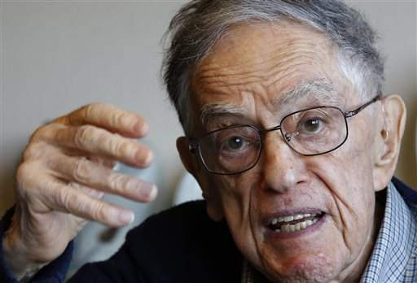

In this Monday, Dec. 28, 2015 photo, Donald Keene speaks during an interview at his home in Tokyo. Keene persevered, arriving in the ancient Japanese imperial capital of Kyoto in 1953 to do research. From those beginnings he counts about 25 books in English and 30 in Japanese and more than six decades of teaching. He’s considered a giant in the field he helped build, translation and Japanese literature. His life has become so intertwined with Japan that he has decided to spend his remaining years here, becoming a Japanese citizen in 2012. (AP Photo/Shizuo Kambayashi)

TOKYO (AP) — So few teaching opportunities existed for a young Japan scholar in late 1940s America that a professor suggested he teach Greek instead.
Donald Keene persevered, arriving in the ancient imperial capital of Kyoto in 1953 to do research.
"I was extremely lucky, because the time that I was there was a golden age of Japanese literature," he says. "People didn't speak of it at the time, they all said there's nothing much to read and that sort of thing, but in retrospect we can say this was one of the great periods of Japanese literature. All the famous writers, not only people known because of their previous work, were writing."
Lucky too, he says, because it was a time when few foreigners spoke Japanese, so he easily gained entree to well-known people. Writer Yukio Mishima was a friend.
From those beginnings he counts about 25 books in English and 30 in Japanese and more than six decades of teaching. He's considered a giant in the field he helped build, translation and Japanese literature.
His life has become so intertwined with Japan that he has decided to spend his remaining years here, becoming a Japanese citizen in 2012.
"I gradually thought of Japan as a place where I would like to live, and also where I would like to die," he says at his Tokyo apartment, which overlooks a leafy public garden that was the estate of a wealthy 19th-century businessman. "And the disaster in Fukushima made me feel that I must do something."
Though his memory isn't what it once was, the longtime Columbia University professor remains active. He becomes animated when talking, his eyes gleaming in a way that conveys an earnest interest in the subject. His latest book — about the early 20th-century poet Takuboko Ishikawa — will be published in Japanese in February, and he hopes an English edition will follow later in 2016.
His decision to settle in Japan in 2011, at a time when many foreigners were fleeing because of the meltdowns at the Fukushima nuclear plant, made him something of a hero in Japan, where he had already been widely honored by the government and others for his scholarly work.
"It was a time when what I did, which was minor and personal, became something of great importance," he says. "I became a famous person in a sense. And the Japanese were extremely grateful. I gave them what I could give them. And since then I have continued to have an interesting life. I'm now 93, and just completed a book, and I hope I can keep on going."
As a university student in 1940, Keene came across a copy of "The Tale of Genji," an 11th-century Japanese classic, in a New York bookshop. It changed his life. The two-volume translation by Englishman Arthur Waley seemed a bargain at 49 cents, Keene wrote in a 2008 memoir. It has since been translated three more times, but never by Keene.
"If one is a translator of Japanese, one should take the most famous work and try it, and show what you can do with it," he says. "I never had that feeling because I worship Waley. I didn't want to do anything against what he had done."
In Genji, Keene found an alternative to the emerging war in Europe. "People were trying their best to make everything beautiful. Their language, what they wore, the flowers they grew, everything," he says. "I just felt a hatred for everything that was going on, and Waley saved me."
He learned Japanese in U.S. Navy language school and interrogated Japanese prisoners in Okinawa during World War II.
Keene sees a declining interest today in traditional Japanese arts. He senses that Japan's best minds gravitate toward science in a modern, more materialistic world.
As for himself, "it's become more difficult to write than before," he says. "I'll forget things that I know I knew at one time. The name of a person, the name of a place. So I think I may have written my last major work, but I will go on writing other things and giving lectures."

The Daily Astorian
December 30, 2015
________________

IN MEMORIAM
MARSHALL GREEN
Class of 1935
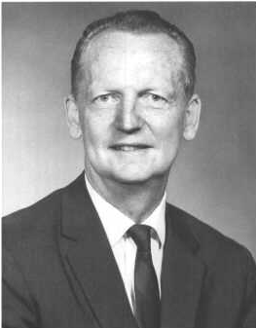

Marshall Green, a star of what has been termed the Golden Age of the American Foreign Service in the decades after World War II, died while playing golf with his son Mark (’60) outside Washington D.C. on June 6, 1999.
Marshall’s career began with a two-year term as private secretary to Ambassador Joseph C. Grew (Groton 1898) in Tokyo, 1939-41. Following three years as a U.S. Navy trained Japanese translator arid interpreter, he joined the Foreign Service in 1945 and embarked on a succession of extraordinarily challenging and important assignments. They included principal assistant to Secretary of State Dulles in his management of the Taiwan Offshore Islands crisis of 1958; Chargé of our Embassy in Korea during General Park’s 1961 overthrow of the democratically elected Chang government; Consul General in Hong Kong 1961-63 when that outpost city was the West’s eyes and ears on Communist China; Ambassador to Indonesia during the 1965 overthrow of President Sukarno by General Suharto; Assistant Secretary of State for East Asian and Pacific Affairs 1969-73, when he served as a key Assistant to President Nixon and Secretary of State Kissinger in their opening to China and conduct of the Vietnam War; and as Ambassador to Australia 1973-75, when his low-key, persuasive diplomacy was instrumental to the marked improvement of U.S.-Australian relations in that period.
Long concerned over the silent explosion of population growth in East Asia and most of the rest of the developing world, Marshall resigned in 1975 from his Australian assignment to establish and fill the position of State Department Coordinator of Population Affairs. He resigned from that position and the Foreign Service in 1979, joined a leading Washington non-profit population organization, the Population Crisis Committee, and devoted a major share of his attention to the world population problem throughout his extremely active retirement years.
Dedicated from his earliest years to the public interest and public service, Marshall believed that the Foreign Service should promote not just U.S. national interests but the welfare of all mankind on this unforgiving planet. He never tired of emphasizing that rights must be accompanied by responsibility. And he many times exemplified in his personal positions on public issues his conviction of the importance of courage—the courage to stand up for what one believes.
At the same time, Marshall was a genuinely humble and kindly individual incapable of pomposity or conceit. His concern for and loyalty to friends and staff were deep seated and unwavering. Possessed of unfailing good cheer and an irrepressible sense of humor, he was for forty years one of the Service’s most widely known, admired and best liked members. The death of his wife and Foreign Service partner of 54 years, Lisa, in 1996 was a devastating blow. But not even that could long discourage him and he maintained an amazing volume and variety of writing, speaking, travel and sports activities, including his beloved golf and bicycling.
I can do no better in attempting to review Marshall’s extraordinary qualities and career than to quote from his senior State Department colleagues’ remarks at his Washington memorial service:
William P. Bundy. "It was endlessly right that Marshall should have started his career in Tokyo under Ambassador Grew -- and that he went on to the very top, extraordinary in his grasp of East Asia and wise on any issue, admired and beloved by all who served with and under him."
Ambassador Thomas Shoesmith (Ret.). "During the Korean military coup, while Washington dithered, Marshall, then Chargé d'Affaires of our Embassy, unhesitatingly acted in support of democratic and constitutional principles. Again, as our Ambassador to Indonesia, during its revolution, it was Marshall's steady hand which guided the shaping of our policy toward that troubled country."
"As Assistant Secretary of State for East Asian Affairs, Marshall confronted a difficult policy decision regarding the extension of bombing raids into Cambodia. I still remember clearly how heartened and encouraged we in the Bureau were to learn of his courageous defense of his opposing position, along with his firm injunction to us to loyally support the final decision."
"Marshall was the 'compleat' diplomat, effective in his leadership, perceptive and imaginative in his policy prescriptions. But there was another very human and endearing side, Marshall's humor and wit, which could relieve tensions and brighten one's day. George Kennan put it best in commenting on Marshall's delightful book, 'Pacific Encounters:'
"No one has ever described with a more delicate and irrepressible sense of humor how the many crucial and dangerous moments of a long Foreign Service career in the Far East are coupled with the equally numerous ironies and absurdities that attend it.'"
Ambassador Paul Cleveland (Ret.). "Recognizing the significance of Asians' nationalism before others and perceiving their need and desire to develop skills and self esteem, Marshall translated his policy of helping Indonesians help themselves into the Guam Doctrine, wherein we proposed to help Asians everywhere help themselves. He saw his vision transformed into the Nixon Doctrine--something different--a rationale for removing our forces from Vietnam, leaving the Indochinese to carry on largely on their own."
"Deeply frustrated by the course of conflict in Indochina, particularly in Cambodia where he tried to change our approach, he pressed low key solutions and peace proposals whenever he saw opportunity. Sometimes it seemed quixotic. One day following the incursion into Cambodia he burst from his office to announce: "I know what we are doing in Cambodia!" "What, Marshall?" "We are widening down the war." While his energy, exuberance and optimism never failed him, it sometimes masked deep frustration."
"Assigned to Australia, he said he had always wanted to go there. He had indeed, and he loved it. Happily, there was a new challenge. Confronted with Australian antagonism over our military installations, generated by anger over Vietnam, he personally turned the Australians around simply by being the way he was: low key, perceptive, persuasive, indefatigably hopeful, and funny--the Yankee Quipper they called him. He persuaded the Australians to remain among our very closest allies in difficult times and they remain so today."
"Marshall not only thought more clearly and charmed and persuaded more effectively, he did so with purpose and passion, always reined in by his professionalism and his diamond hard New England principles. He was practical and flexible, but mostly he was a deeply moral man and there were things he would not do."
"His devotion to his family, his love and pride in his sons, and above all his love for Lisa, 'Mission Control,' was shaped by these same qualities. It never once wavered. In a telling, poignant moment, his beloved Lisa paused to remark: ‘Do you know, even I can hardly believe, Marshall has never once raised his voice at me in all the time I have known him.' Nor for that matter did he with any of us."
"But in the end what was so unique and winning were the little explosions of suppressed glee and brilliance bubbling at the corners of his mouth; the enthusiasm with which he suddenly recalled from somewhere line after line of Hamlet's soliloquies or discovered Patagonia and its geology at the age of 81; the abiding interest in East Asia and the laser insights that helped him resolve the knottiest diplomatic problems- - in Korea, in Hong Kong, in Indonesia and Australia. His sheer, irrepressible bounce compelled us to love him and follow him naturally in that wondrous parade he and Lisa led through Asia for forty years."
"Perhaps as he strode down the sixth fairway, carrying his clubs as usual, he reflected on Jakarta of the sixties, tried to think of ways to improve our relations with Korea, China and Japan, calculated his and his son Mark's score, and hatched a new pun. We can be sure that he lived his last moments as he always had: fully engaged, firing on all twelve cylinders."
Philander P. Claxton. "Marshall recognized from his own observations in countries where he served and travelled that the burden and danger of rapid population growth was not just the old Malthusian warning of population growth exceeding food supply; it was the massive destruction of the environment. It was the wide unemployment and underemployment caused by immense and increasing numbers of young people moving into the job market for whom there were no jobs. The greatest dangerous consequence was the overcrowding of cities in the developing world, cities doubling in population every 15-20 year's, their teeming slums even faster."
"It is difficult, perhaps impossible, to choose from Marshall's lifetime of devoted and highly effective public service any phase which can be said to transcend others. I do believe, however, from some 50 years--a half century--of friendship with Marshall and observance of his career that his last 22 years, trying and succeeding to help hundreds of millions of people all over the world to control their fertility, truly capped his career."
Marshall throughout his life looked back to and blessed his Groton roots. He sent two sons to Groton and in 1990 gave the commencement address. Of the many who have gone on from Groton to lives of public service he deserves to be remembered and honored with the best.

Robert A. Fearey
Class of 1937
As published in the
Groton School Quarterly
1999

[Ed. Note: We previously posted the New York Times obituary for Ambassador Green, but this is a much different memorial piece.]
________________

Paul P. Anspach
JLS 1943

ANSPACH -- Paul Parker Anspach Jr., 78, a resident of Tucson, Arizona, passed away June 21. He was born to Paul Parker Anspach Sr. and Sylvia Anspach, June 17, 1921 in Dayton, Ohio and raised in China and Korea before the Japanese occupation period. After they and other Lutheran missionaries were expelled, he entered the military and served from 1942-1946 as an intelligence officer and translator for the US Navy. Following War II, he attended seminary at Wittenberg College, and was ordained a Lutheran Minister in 1950. In June of the same year, he married Miriam Ann Lauver in Springfield, Ohio. The couple traveled immediately to Japan, where Reverend Anspach served as a missionary in Kyoto, Nishinomiya, and Isahaya for the next 17 years. During their stay in Kyoto, the Anspachs were blessed with four children, Deborah Ann, Jennifer Lynn, Joel Eric, and Jonathan Paul. Reverend Anspach and his family returned to the United States in August of 1967, when he was called to Bethlehem Lutheran Church in Los Alamos, NM. He served as Bethlehem's Pastor until 1982. When he returned to Japan to teach English and history at Baiko Women's College in Shimonoseki. He retired in Tucson in 1989, where he had been an active member of the Dove of Peace Lutheran Church (Tucson church). He is survived by daughters, Deborah Anspach and husband, John Hanson of Billings, MT and Jennifer Gillaspie and husband, Barry Gillaspie of Tucson, AZ; sons, Joel Anspach and wife, Leesa Lederer of Albuquerque and Jonathan Anspach and wife, Denise Anspach of Albuquerque; grandsons, Josh Anspach-Hanson and Eric Anspach-Hanson of Billings, and Ian Anspach Gillaspie of Tucson. Surviving siblings include Carolyn Anspach Sunburn, Phyllis Anspach Thompson, Sarah Anspach Kepple and Thomas E. Anspach. He is also survived by the many families and friends whose lives were both touched and changed through his ministry on two continents.
Albuquerque Journal
June 22, 1999

[Ed. Note: A much shorter obituary was posted from his alumni magazine. This obituary is much more complete.]
________________

Dayton George Howe
OLS (Russian) 1945
1922-2014
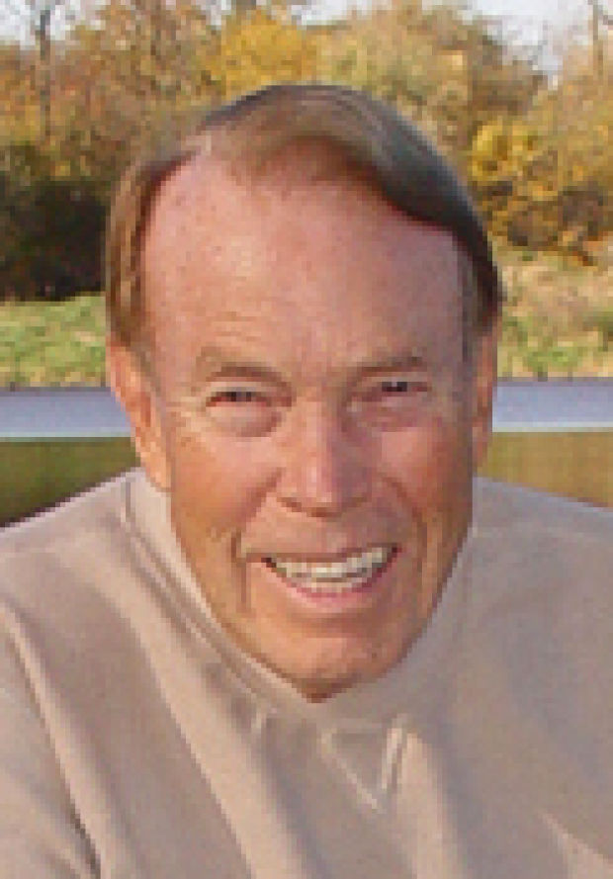

BETTENDORF, Iowa--Dayton George Howe, 92, of Bettendorf, formerly of DeWitt, died on Sunday, December 21, 2014.
Dayton was born on July 10, 1922, in Muscatine, the son of Merrill and Thelma Howe. He graduated from the University of Iowa in 1943 with a degree in business administration.
While serving as a lieutenant in Naval Intelligence, he attended the Oriental Language School in Boulder, Colorado, where he learned to speak fluent Russian. He was stationed in Washington, D.C. during both World War II and the Korean Conflict.
On September 16, 1945, he married Doris Lothringer of Davenport. Together they had five children.
For 26 years Dayton worked for Alden's, where he served as general manager of department stores in Indiana, Illinois, and Iowa. In 1972, he purchased W.H. Walker & Co. in DeWitt, which he ran for 14 years. In addition, he owned Barton's and Abby's in Muscatine.
Civic responsibility was important to Dayton. He served on the board of the University of Dubuque, United Fund, DeWitt Chamber of Commerce, and the Clinton County Conservation Board.
Dayton lived in DeWitt for almost forty years, moved to The Fountains in Bettendorf, and most recently to Cincinnati, Ohio.
Dayton loved to travel, and was an active and youthful man during his very long life. He was a loyal friend and mentor to many, and was dedicated to conservation. A loving and committed family man, he is survived by his brother and sister-in-law Stan and Helen Howe; his five children, Bruce, Barbara, Jane, John, and Alexandra; and his five grandchildren, Austin, Elise, Drew, Madeleine, and Vivian.

Quad City Times
January 22, 2015
________________

$Donations Accepted

If you wish to support the JLS/OLS Archival Project you may contribute to our US Navy JLS/OLS Fund. Contributions are used to hire students to work on the USN JLS/OLS Archival Project, to prepare and mail the newsletter, to survey, inventory and process collections, and to scan photographs. To donate, make your check out to the University of Colorado, writing US Navy JLS Fund on the memo line to the bottom left of your check, and mail it to our contact address.

David Hays
Special Collections & Archives
University of Colorado Boulder Libraries
184 UCB
Boulder, Colorado 80309-0184
________________

