The US Navy Japanese/Oriental Language School Archival Project

The Interpreter
Archives, University of Colorado at Boulder Libraries

Number 64A Remember September 11, 2001 | June 15, 2003

Our Mission

In the Spring of 2000, the Archives continued the original efforts of Captain Roger Pineau and William Hudson, and the Archives first attempts in 1992, to gather the papers, letters, photographs, and records of graduates of the US Navy Japanese/ Oriental Language School, University of Colorado at Boulder, 1942-1946. We assemble these papers in recognition of the contributions made by JLS/OLS instructors and graduates to the War effort in the Pacific and the Cold War, to the creation of East Asian language programs across the country, and to the development of Japanese-American cultural reconciliation programs after World War II.

Samoa Language School

[Ed. Note: Harry D. Pratt and Elmer J. Stone adapted the following from the article, “Parley-Voo Japanese”, published in the Marine Corps magazine The Leatherneck, December 1942. Quoted material is from the article.]

Among the national concerns generated by the December 7, 1941 attack on Pearl Harbor was the woeful dearth of Japanese language speakers in our military forces. As previously chronicled in the Interpreter the Navy had anticipated this need by training a few Naval and Marine officers in Japan from 1920 to 1940. With the commencement of hostilities the need for an immediate expansion of language education programs became apparent. Concurrently, Japan’s lightning conquest of vast areas of the Western Pacific alarmed American planners who moved quickly to protect the vital lifeline to New Zealand and Australia. Key to this objective was fortifying American Samoa and this fell to the 2nd Marine Brigade that on January 7, 1942 boarded hastily converted luxury passenger ships, the Lurline, Monterey and Matsonia, for the 13-day voyage from San Diego to Pago Pago.
Enroute to Samoa Major Ferdinand Bishop, a Brigade intelligence officer and a graduate of the Tokyo program, finalized plans to open and teach a Japanese language course for Marines garrisoned on the island. The method of instruction was to follow that employed in the Tokyo Embassy program that had as its foundation the Naganuma Hyojun Tokuhon, the same as used in the JLS. The curriculum formulated by Bishop included Naganuma Book One, introduction to gyosho and sosho, military vocabulary, Japanese personal and place names, Japanese, Pacific and East Asia geography, Japanese military history and customs and military interrogation. Prior to the war several Japanese- English and English-Japanese dictionaries had been reproduced in the United States. Included were Kenkyusha’s Waei, Sanseido Eiwa, Rose-Innes Kanji Jiten and others. Ultimately each student received a personal copy of these volumes and after graduation they were protectively carried into combat, over reefs, through salt water, jungles and wherever else their custodians might find themselves.
Upon arrival in Samoa Bishop located, in his words, “a tin-roofed shanty under the palms” to serve as a hall of learning and a nearby “native thatch hut” to serve as a dormitory for the enlisted students. A Brigade memorandum to all units announced the formation of the school and solicited applications for admission to the six months of instruction. Major Bishop screened the applications, selected a number for in-depth interviews and in the end three officers and 13 enlisted men were enrolled and classes commenced. Within a few weeks, owing to ineptitude, a transfer and an illness, the number was reduced to one officer and seven enlisted men.
An accomplished scholar Bishop also proved to be an effective teacher and taskmaster. Except for the necessities of life and Sunday mornings, the students’ waking hours were reserved for lectures, study and occasional mandatory guard duty. Being in a war zone the “tin-roofed shanty” was equipped with blackout curtains to permit the required nighttime study.
“The first week of the course opened with lectures on historical and military background of the Japanese, leading up to a study of the characteristics, psychology, and problems of the various strata of Japanese society. Actual language study began with simple phrases, class pronunciation drill, conversation practice, study of Hiragana syllabary (sic) and the learning of 15 kana, or composite symbols, each day.” Over the following 23 weeks the class mastered Naganuma Book One and learned to read and write the 500 kanji and compounds in that volume. Distinguishing features of the curriculum were the emphasis on Japanese order of battle, military terms and customs, historical background, relevant geography and interrogation techniques.
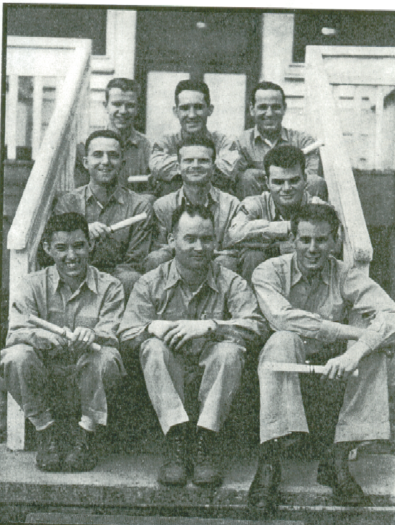

All eight of the graduates went on to language work with Marine combat units in the Guadalcanal and subsequent campaigns. Of the seven enlisted men five were ultimately elevated to officer rank. Five of the graduates (Col. Harry D. Pratt, Lt. Colonel William R. Croyle, Maj. Ralph A. Baker, Maj. Elmer J. Stone and Lt. Seldon L. Brown) went on to the JLS for advanced training preparatory to the planned invasion of Japan.
_______________

Later JLS Classes MIA

My class is conspicuously absent. I will give you a few names but 1945 (when I was at Boulder) is a long time ago and my memory is not very good anymore. Plus, I have not kept up with any of my classmates. I lived in the fraternity house across from the stadium. I have some pictures but I don’t know where they are. They were taken from our dorm when there was nothing between us and the mountains.
Leonard Rush
OLS 1946
_______________

Marion Levy Jr., JLS 1943,

Dies at 83

Marion J. Levy Jr., a scholar of sociology and international affairs who wrote about modernization theory, died on May 26 in Princeton, N.J., where he lived. He was 83.
The cause was complications from Parkinson's disease, according to Princeton University.
Dr. Levy retired in 1989 as Musgrave Professor of Sociology and International Affairs at Princeton. He had taught there since 1947 and was chairman of its department of East Asian studies for a time.
He once said that "the fundamental problem posed by modernization is whether human animals can adjust as readily to longevity, affluence, and peace as they have in the past to shortgevity, poverty, and war." He predicted that life in a modernized world "is likely to become crowded, affluent, nasty, brutish and long."
His writings include the book "Modernization: Latecomers and Survivors" (1972), and the two-volume work "Modernization and the Structure of Societies" (1966), which examined the differences between societies that were relatively nonmodernized and those that were relatively modernized. He carried out innovative scholarship about why Japan, not China, was in the vanguard of modernization in Asia, concluding that while many assumed the two countries were

Mike Foley

I met Mike at the University of Washington when I was beginning my graduate work there in the fall of 1940. We were both from Montana and formed a pleasant friendship.
Four years later, in May 1944, I was part of the group recently graduated from the JLS which reported for duty at JICPOA, Pearl Harbor. Mike was in charge of the weather section of the Japanese language department and kindly arranged for me to become a member. It was exactly the right kind of assignment for me, and I enjoyed the work and our small, congenial team. I was impressed
similar when they were first opened to Western influence, in reality the similarities were only superficial.
Marion Joseph Levy was born and raised in Galveston, Texas.
He transferred from Berkley to Boulder in 1942. He was a Navy
lieutenant in Asia in World War II and received a doctorate in sociology from Harvard.
He is survived by his wife, Joy; a daughter, Dore J. Levy of Providence, R.I., who is a professor of comparative literature and East Asian studies

by Mike’s facile command of Japanese and once again by his easy friendliness.
We resumed contact some years ago, and he and Inez were good enough to pay us a visit in Redding on one of their trips to the West Coast. We also got together at the last two JLS Reunions.
He was a very special person, and Muriel and I were deeply saddened by his unexpected passing.
Al Weissberg
JLS 1944

[Ed Note: Please feel free to send in any Mike Foley stories and Harry Muheim stories that you can remember. We will be honored to print them up in the newsletter.]
_______________
at Brown; two sons, Noah, of Atlanta, and Amos, of Manhattan; five grandchildren; and a sister, Ruth Levy Kempner of Galveston.
June 17, 2002
Mostly By Eric Pace
The New York Times
_______________

[Ed. Note: Elizabeth Campbell is to be credited for figuring out how to scan and include images in the formerly imageless Interpreter. I hope you find the images an attractive addition to the newsletter.
DMH]

Maxine Good Pineau
Business Woman & Volunteer

Maxine Good Pineau, 82, a volunteer and former businesswoman, died of pulmonary fibrosis April 21 at her home in Bethesda, MD.
Mrs. Pineau was born in Flint, MI. She moved to the Washington area in 1943.
For 15 years in the 1960s and 1970s, Mrs. Pineau was executive secretary of the Washington Ethical Society. She left that position in 1977 after she and two daughters purchased Needlework Attic, a Bethesda knitting and needlepoint shop. They managed that operation for 15 years.
Mrs. Pineau was a 50-year

Contact

David Hays, Archivist II,
Archives,
University of Colorado at Boulder
Campus Box 184
Boulder, Colorado, 80309-0184

Phone (303) 492-7242

Fax (303) 492-3960

Email:
arv@colorado.edu

New JLS Website:
http://www-libraries.colorado.edu/ps/arv/col/jlsp.htm

member of Cedar Lane Unitarian Church in Bethesda, where she was a board member and religious educator. She was a Red Cross volunteer at National Naval Medical Center at Bethesda and at the Children’s Inn at the National Institutes of Health.
Her husband, retired Navy CPT Roger Pineau, died in 1993.
Survivors include four children, Suzanne Pineau of La Jolla, CA, Julienne Hubbard of Washington, DC, Anthony Pineau of Stafford and Antoinette Pineau of Ojai, CA; and four grandchildren.

Washington Post

April 26, 2003
_______________

